Game title

- The Speed of Light.

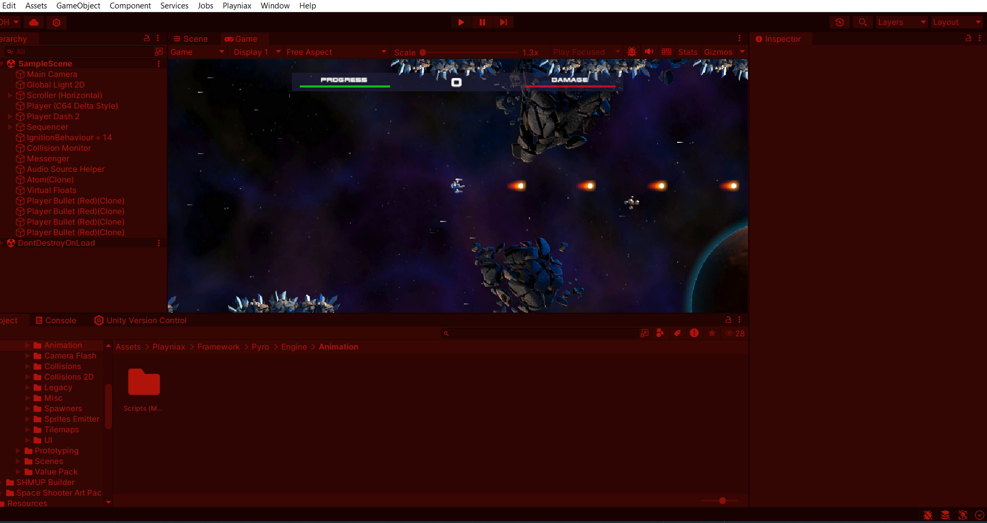

Game design document

Last Updated: 13th June 2024
Version: 1.0

Table of contents

Game overview | 1
Design Pillars | 2
Gameplay overview  Core game loop  Genre  Target platforms  Target audience  Game objectives | 3  3.1  3.2  3.3  3.4  3.5
Game mechanics  Player  Game Characters  Game systems | 4  4.1  4.2  4.3
Story | 5
Characters | 6
Game world | 7
Control scheme | 8

Game overview 1

- Gameplay Synopsis

The game's design, concept, and implementation have been meticulously developed and documented on Miro's mood board. The gameplay is characterized by its fast-paced and dynamic nature, requiring players to constantly strategize and think several steps ahead, similar to the strategic depth found in chess. Players are provided with ample freedom to explore various moves, ensuring they remain engaged and challenged. The presence of diverse and challenging enemies tests players' skills, maintaining a well-balanced experience through minimal reliance on negative and positive feedback loops.

- Difficulty Modes Overview
The game offers four distinct difficulty modes: Easy, Normal, Hard, and Mania. Each mode features a set time limit for completing stages. Failure to complete a stage within this allotted time results in the loss of a life or a 1-up. When players defeat enemies under specific conditions and based on the enemies' skill levels, they may drop time extension icons. These icons grant additional seconds to the player's time limit for the current round. This mechanic introduces a sense of urgency and keeps players engaged and attentive throughout their gameplay experience.

- Urgency Mechanic
The game instills a sense of urgency through a time-limit mechanic, challenging players to demonstrate speed and dexterity with their controllers. Players must quickly navigate and react to stay alive long enough to reach a win state, heightening the intensity and engagement throughout the gameplay.
- Controller and Keyboard Scheme
The image below illustrates the controller and keyboard button layout for the game's movement. This detailed scheme outlines the specific controls for efficient and intuitive navigation, ensuring players can seamlessly interact with the game environment.


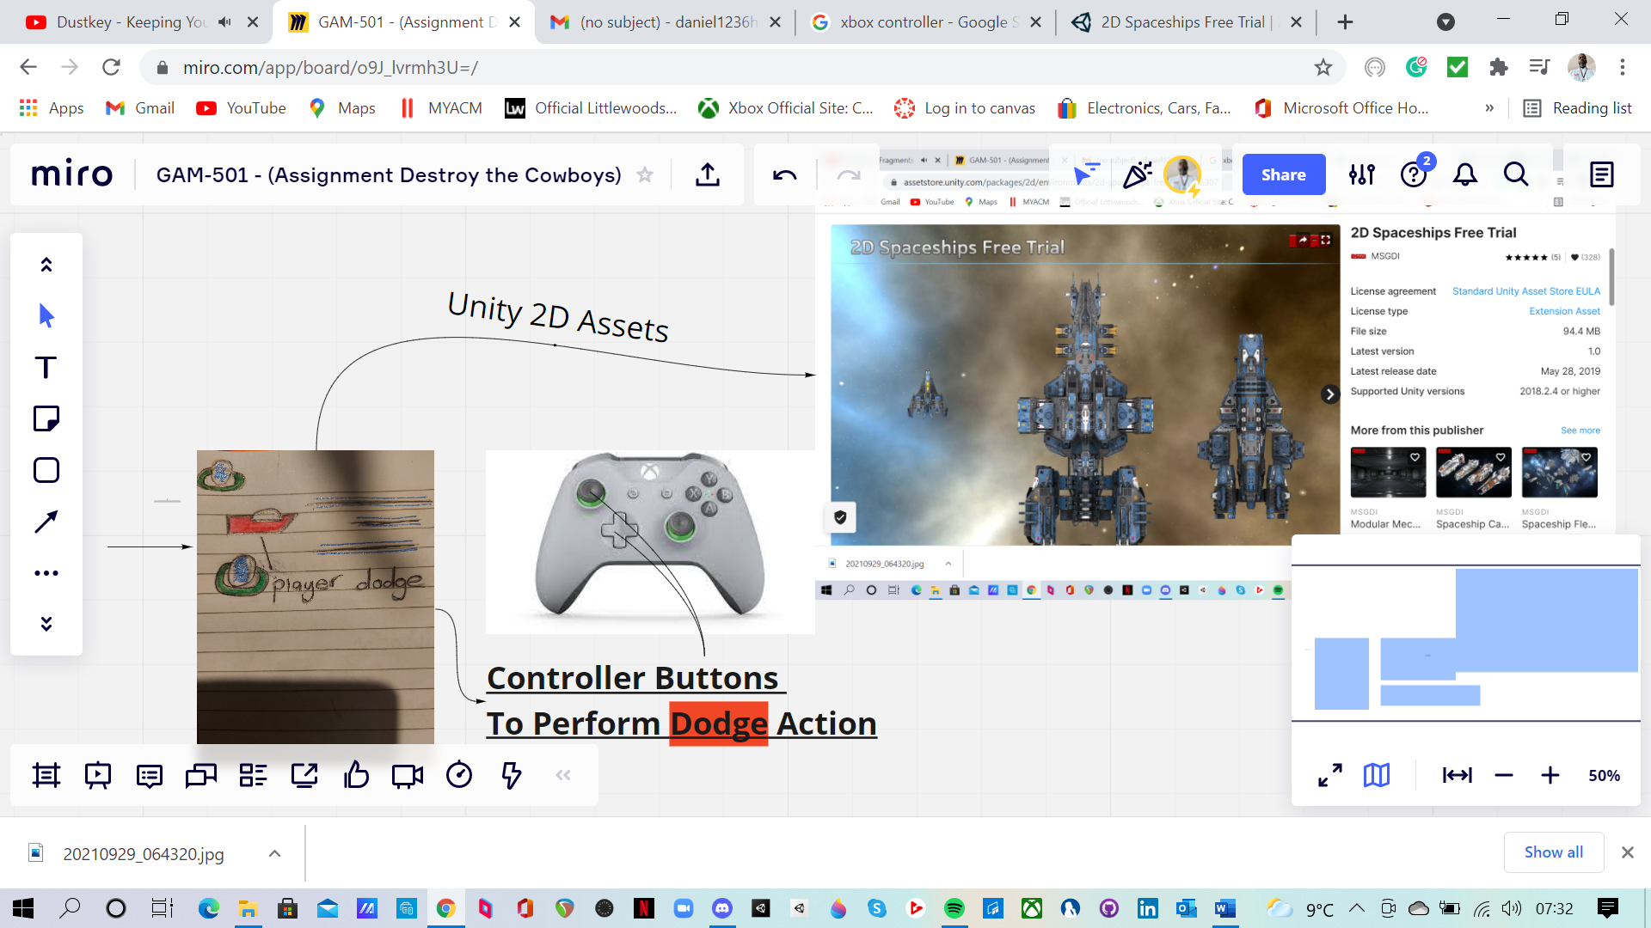

- Enemy Destruction Mechanics
Destroying enemies in this game is more complex and challenging compared to traditional 2D or 3D shoot 'em ups. The enemies are designed to be tough and test the player's skills. The gameplay mechanics have evolved beyond the outdated 2D flying gunship style, embracing innovative design elements that set this game apart. "The Speed of Light" distinguishes itself through its unique and modern approach to enemy engagement, offering a fresh and engaging experience for players.
- Polarity Weapon and Shield Mechanic
The player can acquire a polarity weapon or shield, which grants temporary immunity from attacks. The shield is automatically equipped upon pickup, simplifying the control scheme and reducing the number of buttons the player needs to remember. This streamlined mechanic enhances the gameplay experience by facilitating a state of flow for the player.
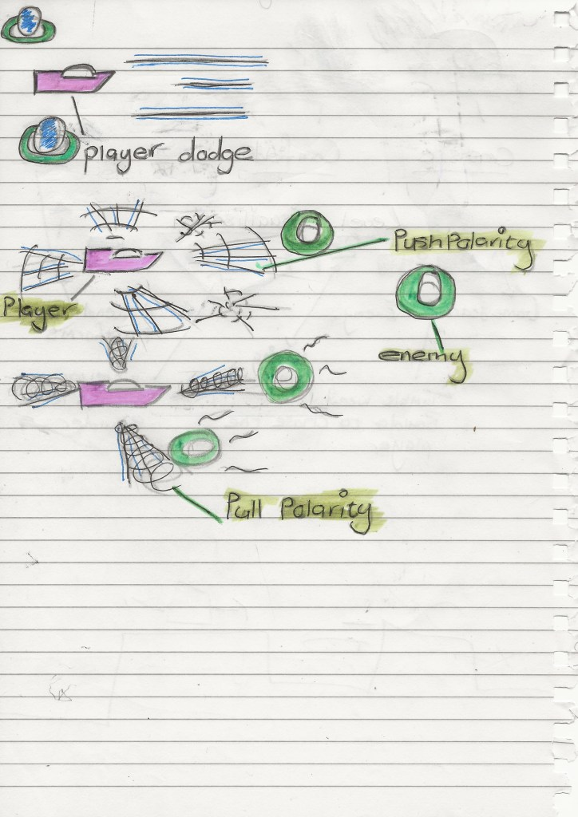
- Gameplay Experience

The game delivers an intense, fast-paced experience, constantly engaging players' senses. Players must remain vigilant, strategizing their attack patterns and thinking one step ahead to effectively counter different types of enemies.
The in-game UI provides real-time updates on the player's health and progress, encouraging continuous advancement. Defeating specific enemies and bosses unlocks new weapons, fostering a sense of achievement and enhancing the game's replay value. This incentive system motivates players to keep progressing, contributing to a deeply satisfying and immersive gameplay experience.

- User Experience
The core of the user experience lies in the seamless interaction between the player and the controller. The controller scheme is designed to be as ergonomic as possible, minimizing finger travel and reducing the number of buttons required. This streamlined design enhances player enjoyment by allowing for automatic weapon fire, enabling players to fully utilize their arsenal against enemies.
With a comprehensive range of abilities mapped to the controller buttons, players will have access to a variety of special weapons and abilities, preventing fatigue and boredom. This ensures continuous engagement and discourages players from quitting the game.
The game offers a challenging experience, immersing players in futuristic gameplay set in the vast depths of space, traversing different solar systems. An enjoyable in-game soundtrack, combined with a dynamic plotline and varied gameplay, further enriches the player experience, making it captivating and memorable.
- Gameplay

The visualization of gameplay, optimized for the standard PC keyboard, significantly enhances player interaction. This thoughtful design ensures an intuitive and engaging experience, allowing players to fully immerse themselves in the game.

- , 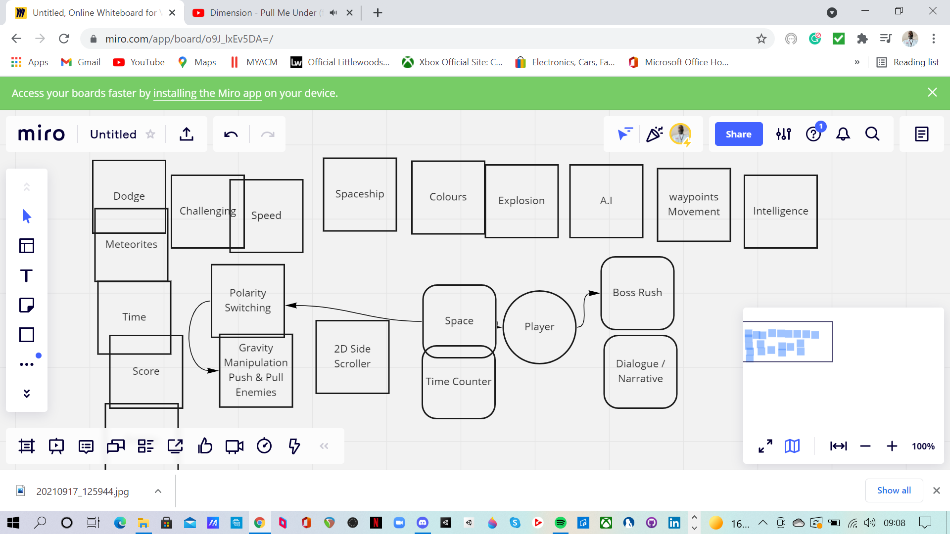

Design Pillars 2
- Player – how does the player interact within the game? What is their role?
In the game, the player takes on the role of a skilled pilot navigating a highly advanced spacecraft. Interaction is facilitated through a thoughtfully designed control scheme that includes both a standard PC keyboard and a streamlined controller setup.
The player's primary responsibilities include:
- Strategic Combat: Players must engage in fast-paced combat, utilizing a range of weapons and abilities to defeat various challenging enemies.
- Time Management: Players need to complete stages within set time limits, collecting time extension icons dropped by defeated enemies to prolong their survival.
- Resource Management: Players can pick up and automatically equip shields, granting temporary immunity and reducing the complexity of controls to maintain fluid gameplay.
- Exploration and Progression: As the game progresses, players explore different solar systems, uncovering new environments and facing increasingly difficult foes.
- Skill Development: Players must think strategically, planning their attack patterns and adapting to the unique behaviors of different enemy types.
Through these interactions, the player experiences a sense of urgency, achievement, and continuous engagement, driving them to advance through the game's dynamic and immersive universe.

- Communication – Communicating Purpose.
Effective communication within the game is essential for conveying its purpose and objectives to the player. This involves:
- Clear Objectives: The game provides explicit goals and tasks at each level, ensuring players understand their immediate and long-term targets.
- In-Game Tutorials and Hints: Interactive tutorials and contextual hints guide players through the mechanics and strategies, facilitating a smoother learning curve.
- Feedback Systems: Real-time feedback, such as health status, progress indicators, and time limits, keeps players informed about their performance and encourages continuous improvement.
- Narrative Elements: A compelling storyline and well-developed characters help to immerse players in the game's universe, making the overall purpose and objectives more relatable and engaging.
- Visual and Audio Cues: Effective use of visual and auditory signals helps players recognize important events, enemy behaviors, and environmental changes, enhancing their situational awareness and strategic planning.
Through these communication strategies, the game effectively conveys its purpose, ensuring players are constantly informed, motivated, and engaged.

- Appeal

The game appeals to players by offering an immersive and challenging experience set in a futuristic universe. Its fast-paced, strategic gameplay requires constant vigilance and quick thinking. The game fosters a sense of urgency with its time-limit mechanics and rewards players with new weapons and abilities for defeating enemies and bosses, creating a continuous incentive to progress. The engaging storyline, dynamic environments, and compelling in-game soundtrack further enhance the overall appeal, ensuring players remain captivated and motivated to keep playing.

- Gameplay Style

The game's style is characterized by its intense, fast-paced action that requires strategic thinking and quick reflexes. Players navigate through a futuristic universe, engaging in challenging combat with a variety of enemies. The game incorporates innovative mechanics, such as time limits and automatic weapon fire, to keep players constantly engaged. The blend of dynamic environments, an evolving storyline, and an immersive soundtrack enhances the overall experience, making it both captivating and rewarding.

- Game Features
The game boasts an extensive arsenal and diverse challenges to keep players engaged. It includes over 14 unique weapons, 20 distinct enemy classes, and 10 formidable bosses. Each element is designed to provide a varied and immersive experience, ensuring that players are constantly faced with new and exciting challenges as they progress through the game.

Gameplay overview 3
Core game loop 3.1
- Engagement: Players enter a stage, immediately engaging in fast-paced combat.
- Strategy: Players must strategize and adapt to enemy behaviors, utilizing their weapons and abilities effectively.
- Time Management: Players are challenged by a time limit, requiring quick decisions and efficient play.
- Progression: Upon defeating enemies and bosses, players earn new weapons and time extensions.
- Feedback: Real-time feedback on health, progress, and achievements keeps players informed and motivated.
- Advancement: Players move to the next stage or solar system, facing new challenges and environments.
This loop ensures continuous engagement, challenge, and reward, fostering an immersive and dynamic gameplay experience.

Genre 3.2
- The game falls within the Action Shooter genre, incorporating elements of both 2D and 3D shoot 'em ups. It blends intense, fast-paced combat with strategic planning and time management, providing a dynamic and engaging experience. The futuristic setting, combined with challenging enemy encounters and innovative mechanics, ensures that players are continually engaged and tested.

Target platforms 3.3
The game is designed to be available on multiple platforms, including:
- PC: Optimized for both keyboard and controller inputs.
- Consoles: Compatible with major gaming consoles such as PlayStation, Xbox, and Nintendo Switch.
- Mobile Devices: Adapted for iOS and Android, ensuring a seamless experience on smartphones and tablets.
This multi-platform approach ensures accessibility and reach to a wide audience of gamers.

Target audience 3.4
The game's target audience includes:
- Action Shooter Enthusiasts: Players who enjoy fast-paced, strategic combat.
- Sci-Fi Fans: Gamers who appreciate futuristic settings and space exploration.
- Competitive Players: Those who thrive on challenging gameplay and leaderboards.
- Casual Gamers: Individuals looking for an engaging and immersive gaming experience across multiple platforms, including PC, consoles, and mobile devices.
- Ages 13 and Up: Teenagers and adults who can handle the game's intensity and complexity.
This diverse audience ensures broad appeal and engagement across various gamer demographics.

Game objectives 3.5

- Complete Levels: Navigate through various stages, each with a set time limit.
- Defeat Enemies: Engage and overcome 20 different enemy classes and 10 challenging bosses.
- Strategic Play: Utilize over 14 unique weapons and strategic planning to defeat foes.
- Time Management: Collect time extension icons to prolong gameplay and ensure stage completion.
- Progress and Unlocks: Advance through the game to unlock new weapons and abilities, enhancing your arsenal.
- Survival: Maintain health and avoid losing lives by effectively using shields and strategic movements.
These objectives ensure a dynamic and engaging gameplay experience, promoting continuous player involvement and achievement.

Game mechanics 4

Lives, 1UP  Defeat Boss | Movement  Keyboard | Special Weapons  Defeat First Enemy Class
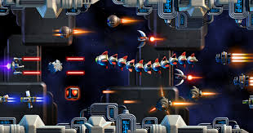 |  | 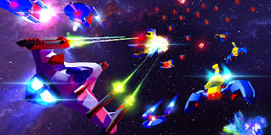

Player 4.1

- You will play as Elia, the pilot of the spacecraft named "The Speed of Light." As Elia, you navigate the spaceship from the cockpit, engaging in intense combat and strategic maneuvers. Your mission involves defeating various enemy classes, challenging bosses, and progressing through different solar systems. Equipped with a wide range of weapons and abilities, you must manage resources, maintain health, and utilize shields to survive and advance. Elia's journey through space is driven by your strategic thinking and quick reflexes, ensuring an immersive and dynamic gameplay experience.

Game characters 4.2
- Elia: The main character and test pilot of the spaceship, "The Speed of Light." Elia sits in the cockpit, navigating the spacecraft through various challenges and combat scenarios, utilizing a wide range of weapons and abilities to defeat enemies and bosses.
- Enemies: The game features 20 distinct enemy classes, each presenting unique challenges that require strategic thinking and quick reflexes to overcome.
- Bosses: There are 10 formidable bosses that test the player's skills and strategic planning.
These characters and elements are designed to provide an engaging and dynamic gameplay experience.

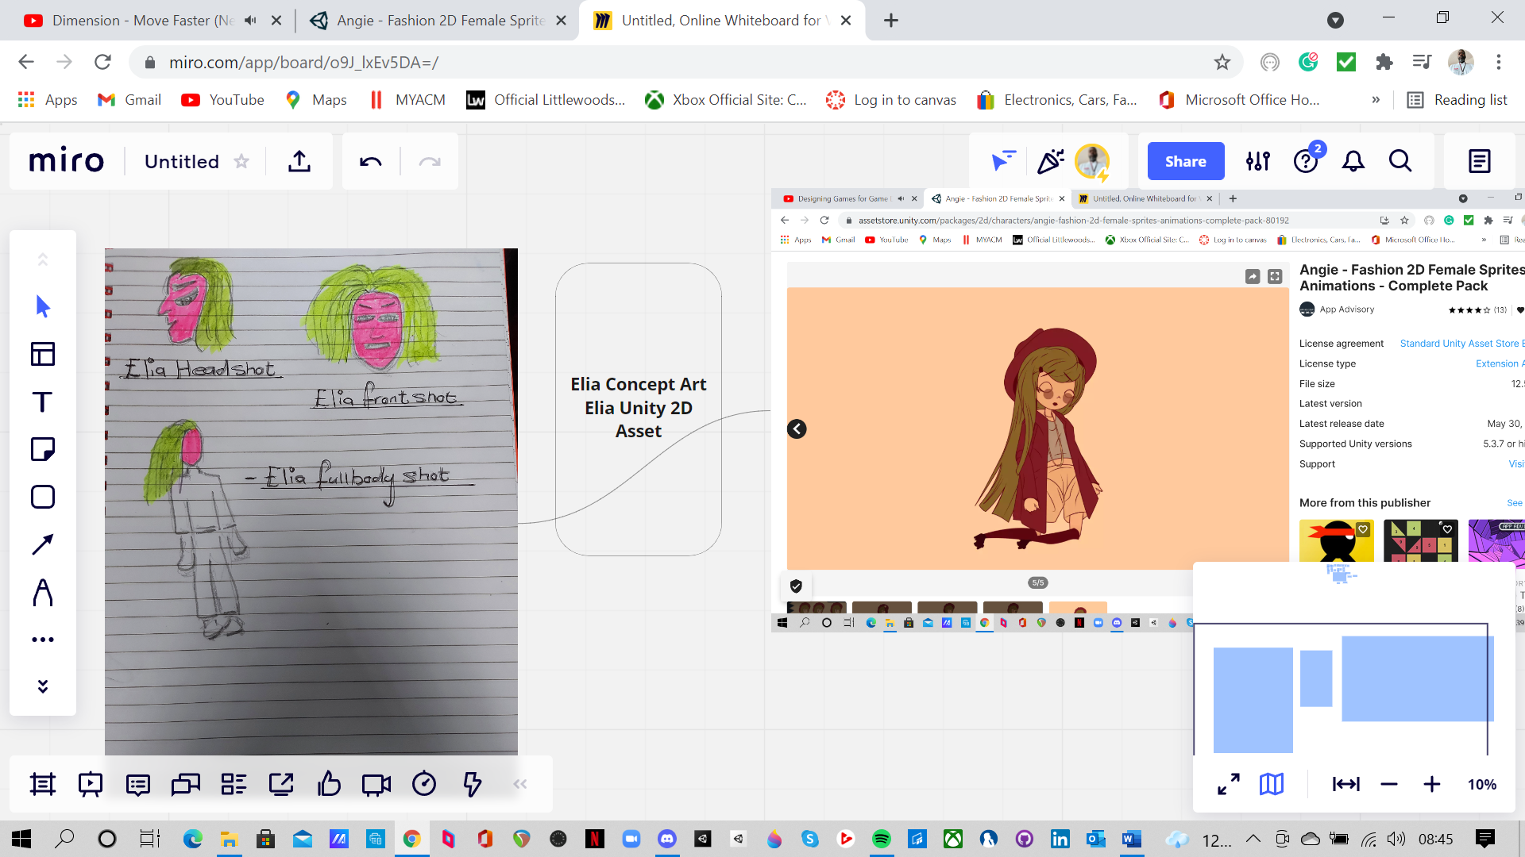
- The speed of light – The new prototype from the United States Air Force.
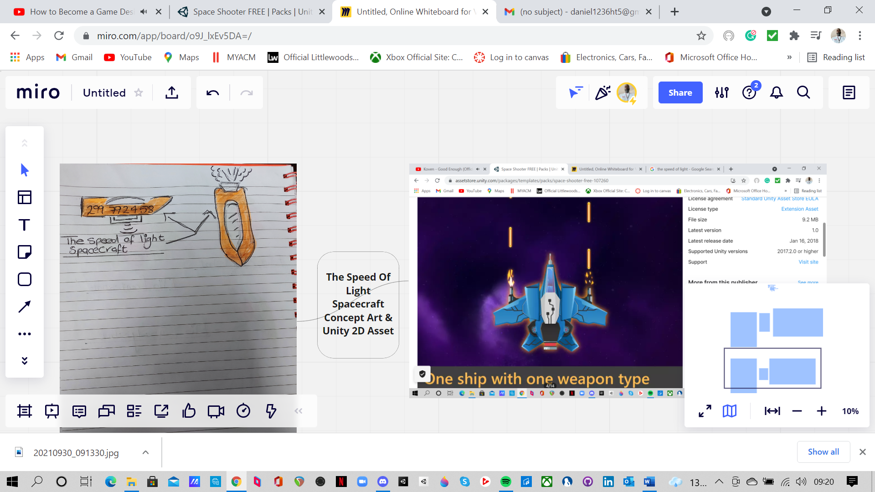

Enemies
- The guard

The guard is protected by a shield that must be destroyed before the guard itself can be targeted. Attacks directed at the guard will be ineffective until its protective shield is eliminated.
- The guard movement pattern

The guard's movement pattern involves moving straight across the screen before reversing direction and homing in on the player's position.
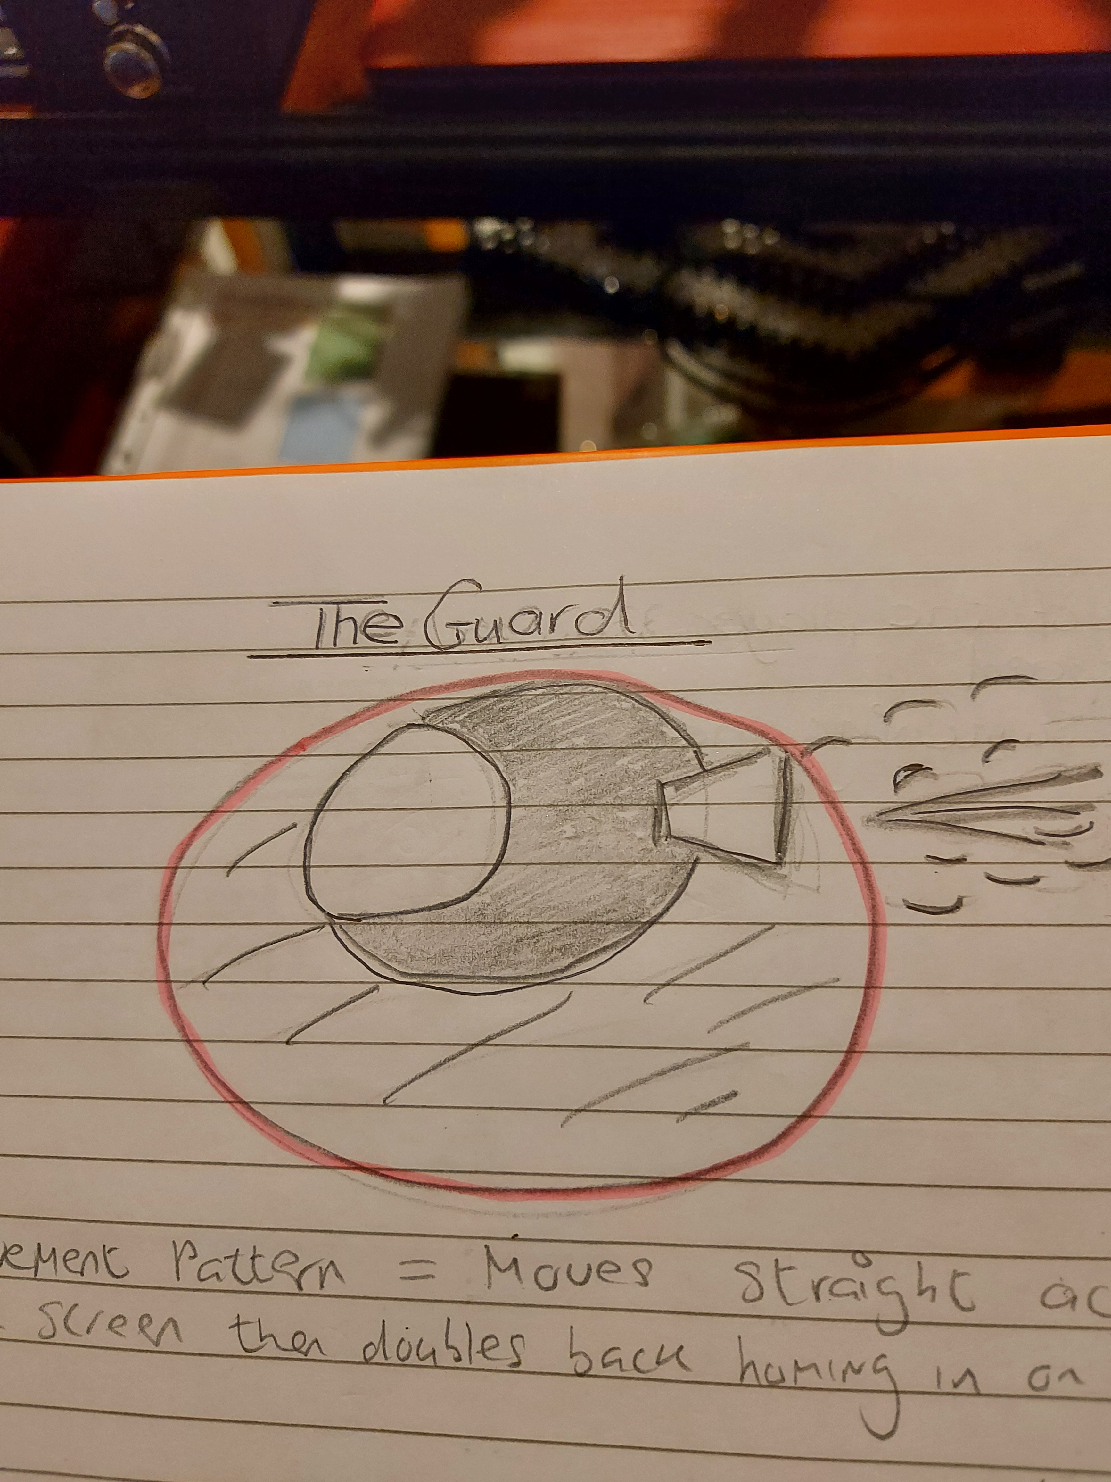

- Clusters

Individual clusters are swift but weak, making them easy to eliminate. However, if left unchecked, they will converge to form a larger cluster. Once clustered, they create a ball that aggressively hurls itself at the player.
- Clusters Movement Pattern

Clusters follow a specific movement pattern: they enter from the right side of the screen, circle around the player once, exit to the left, and then re-enter at either a high or low position.
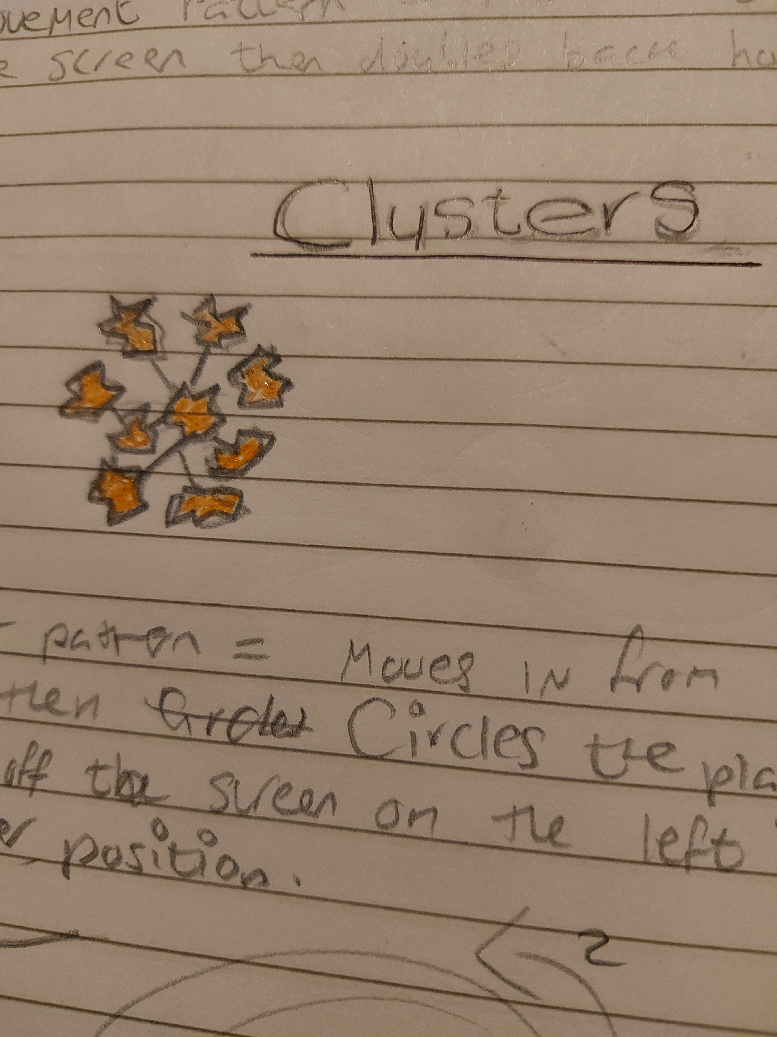

- General Enemies

General Enemies—These generalist adversaries appear throughout the game. They consist of spacecraft from other nations attempting to shoot down or capture the speed of light for their technology.
- General Eniemies movement pattern

General Enemies Movement Pattern – These enemies fly straight towards the player, homing in on their position.

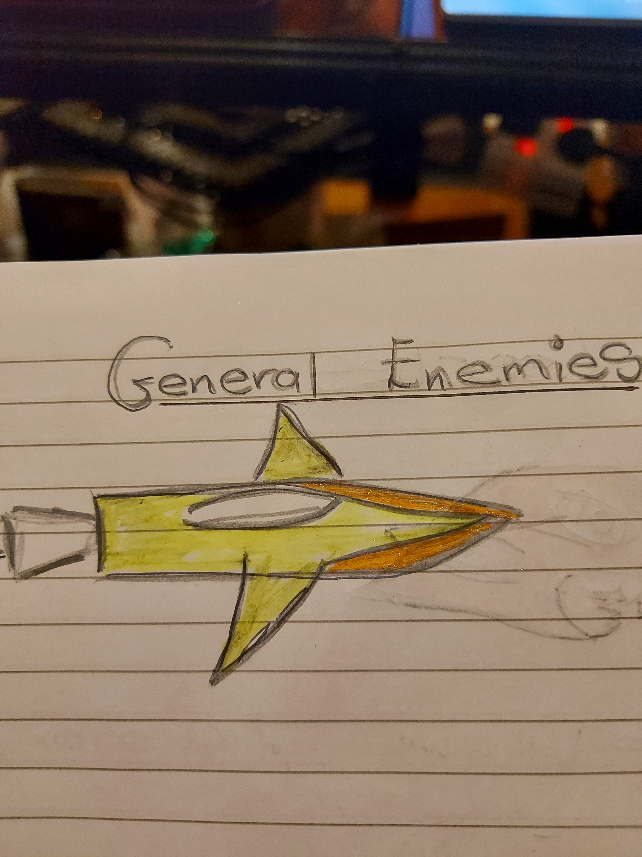

- Meteorites

These dynamic obstacles appear throughout each level, varying in size and speed. They can be overcome similarly to enemies.
- Meteorites Movement Pattern – These obstacles fly diagonally downward towards the player.

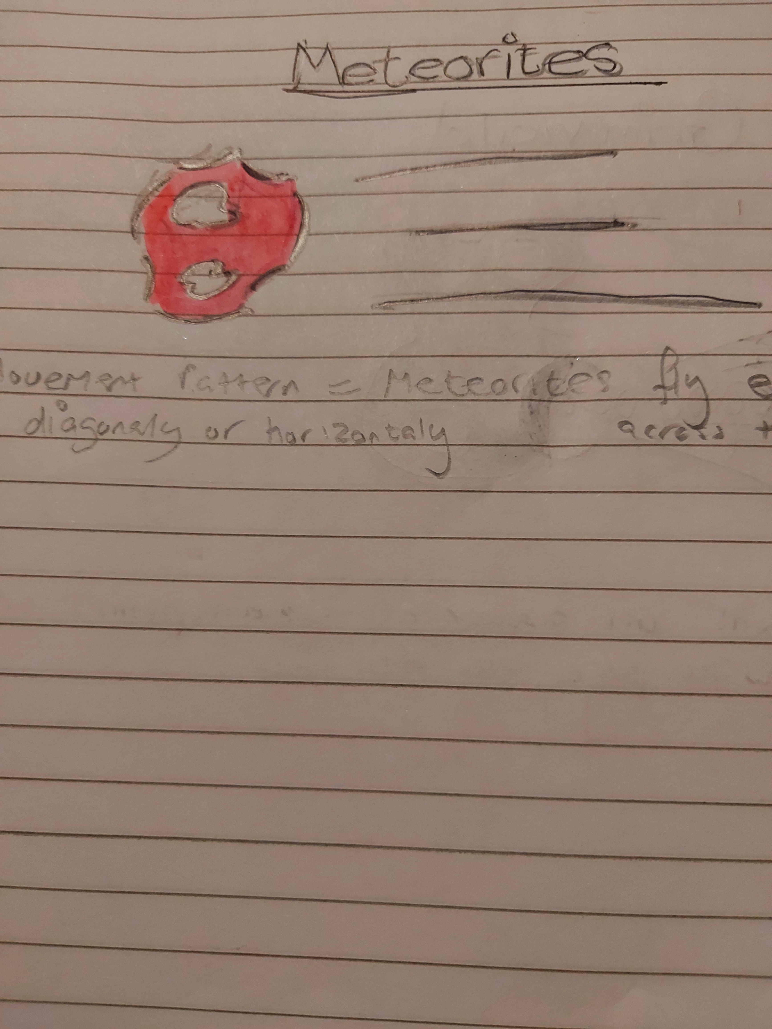

- Leeches

Leeches – These parasitic organisms attach themselves to your spacecraft, draining the player's health meter. They are super quick and very easy to kill.
- Leeches Movement Pattern – These enemies appear above the player and then dive bomb towards them from above.
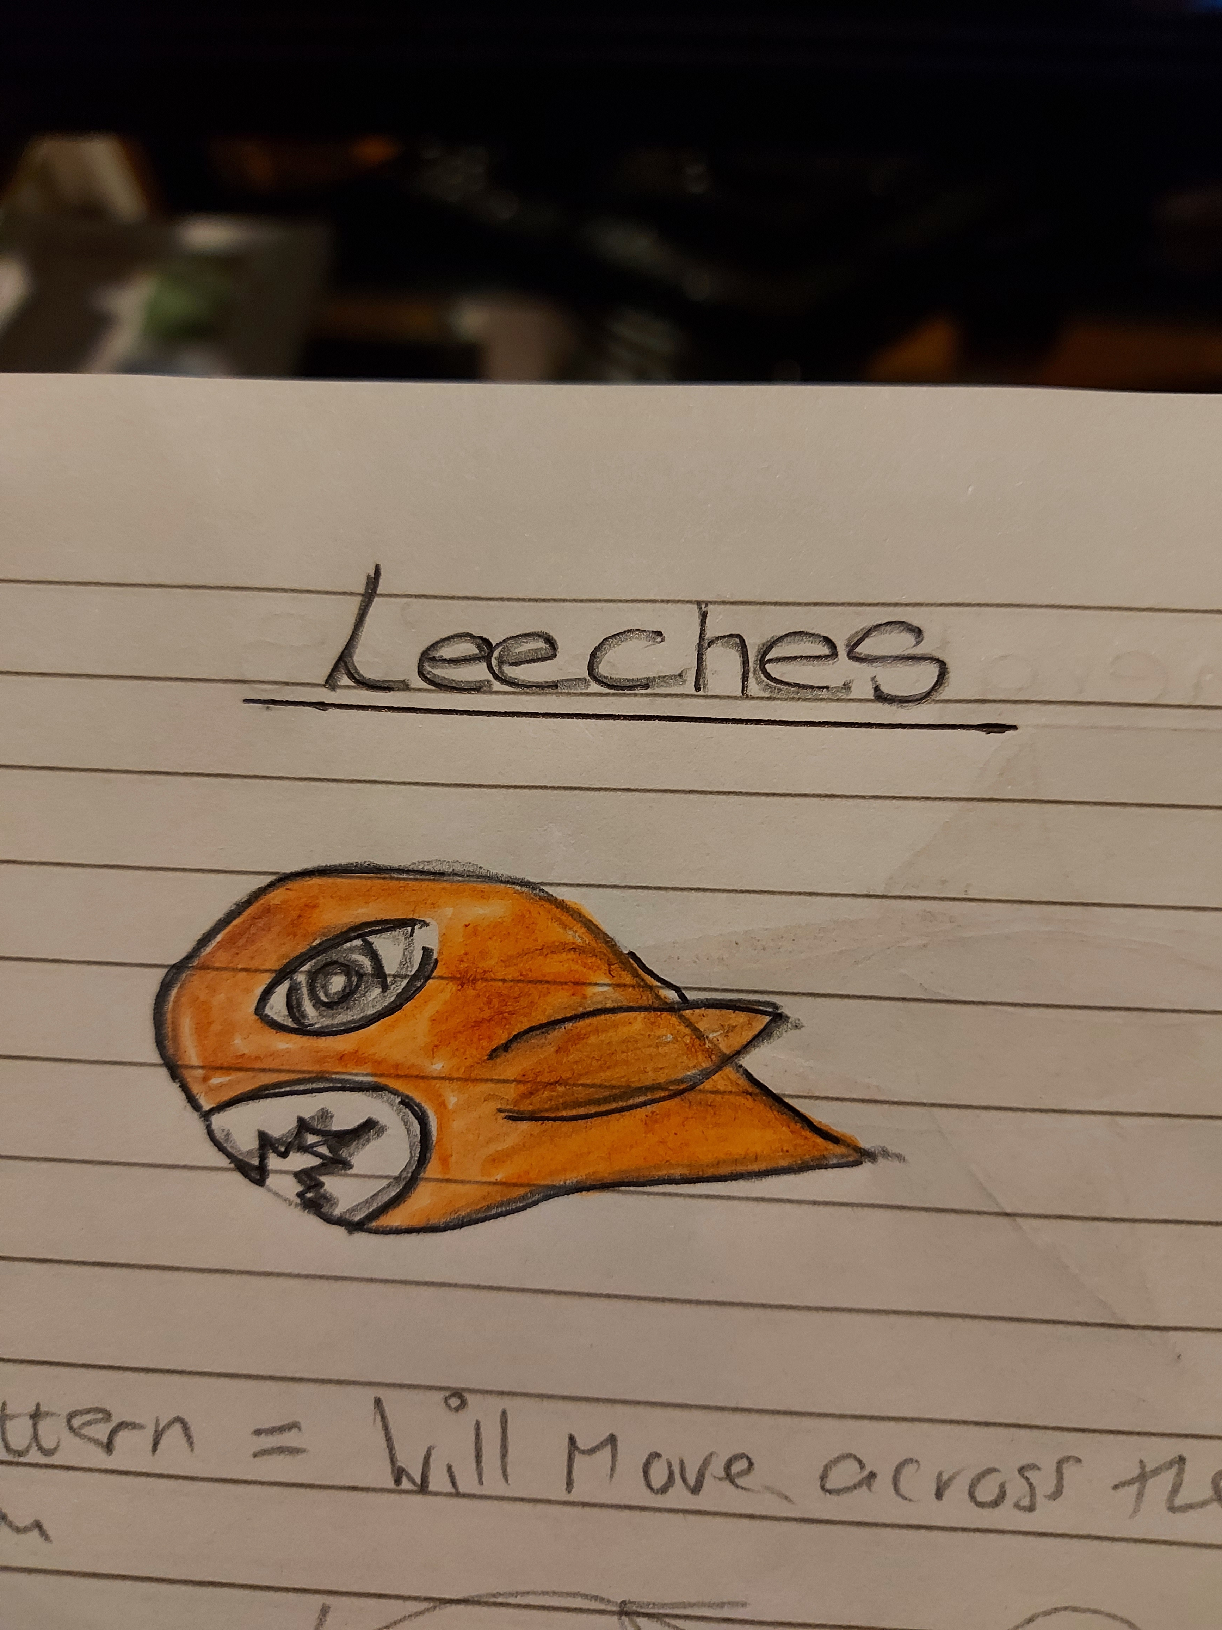

- Grimwald

Grimwald – This enemy creates an energy-draining vortex that pulls you in if you get too close. To defeat Grimwald, attack from a distance and avoid close proximity.
- Grimwald Movement Pattern – Exhibits fast and erratic behavior.
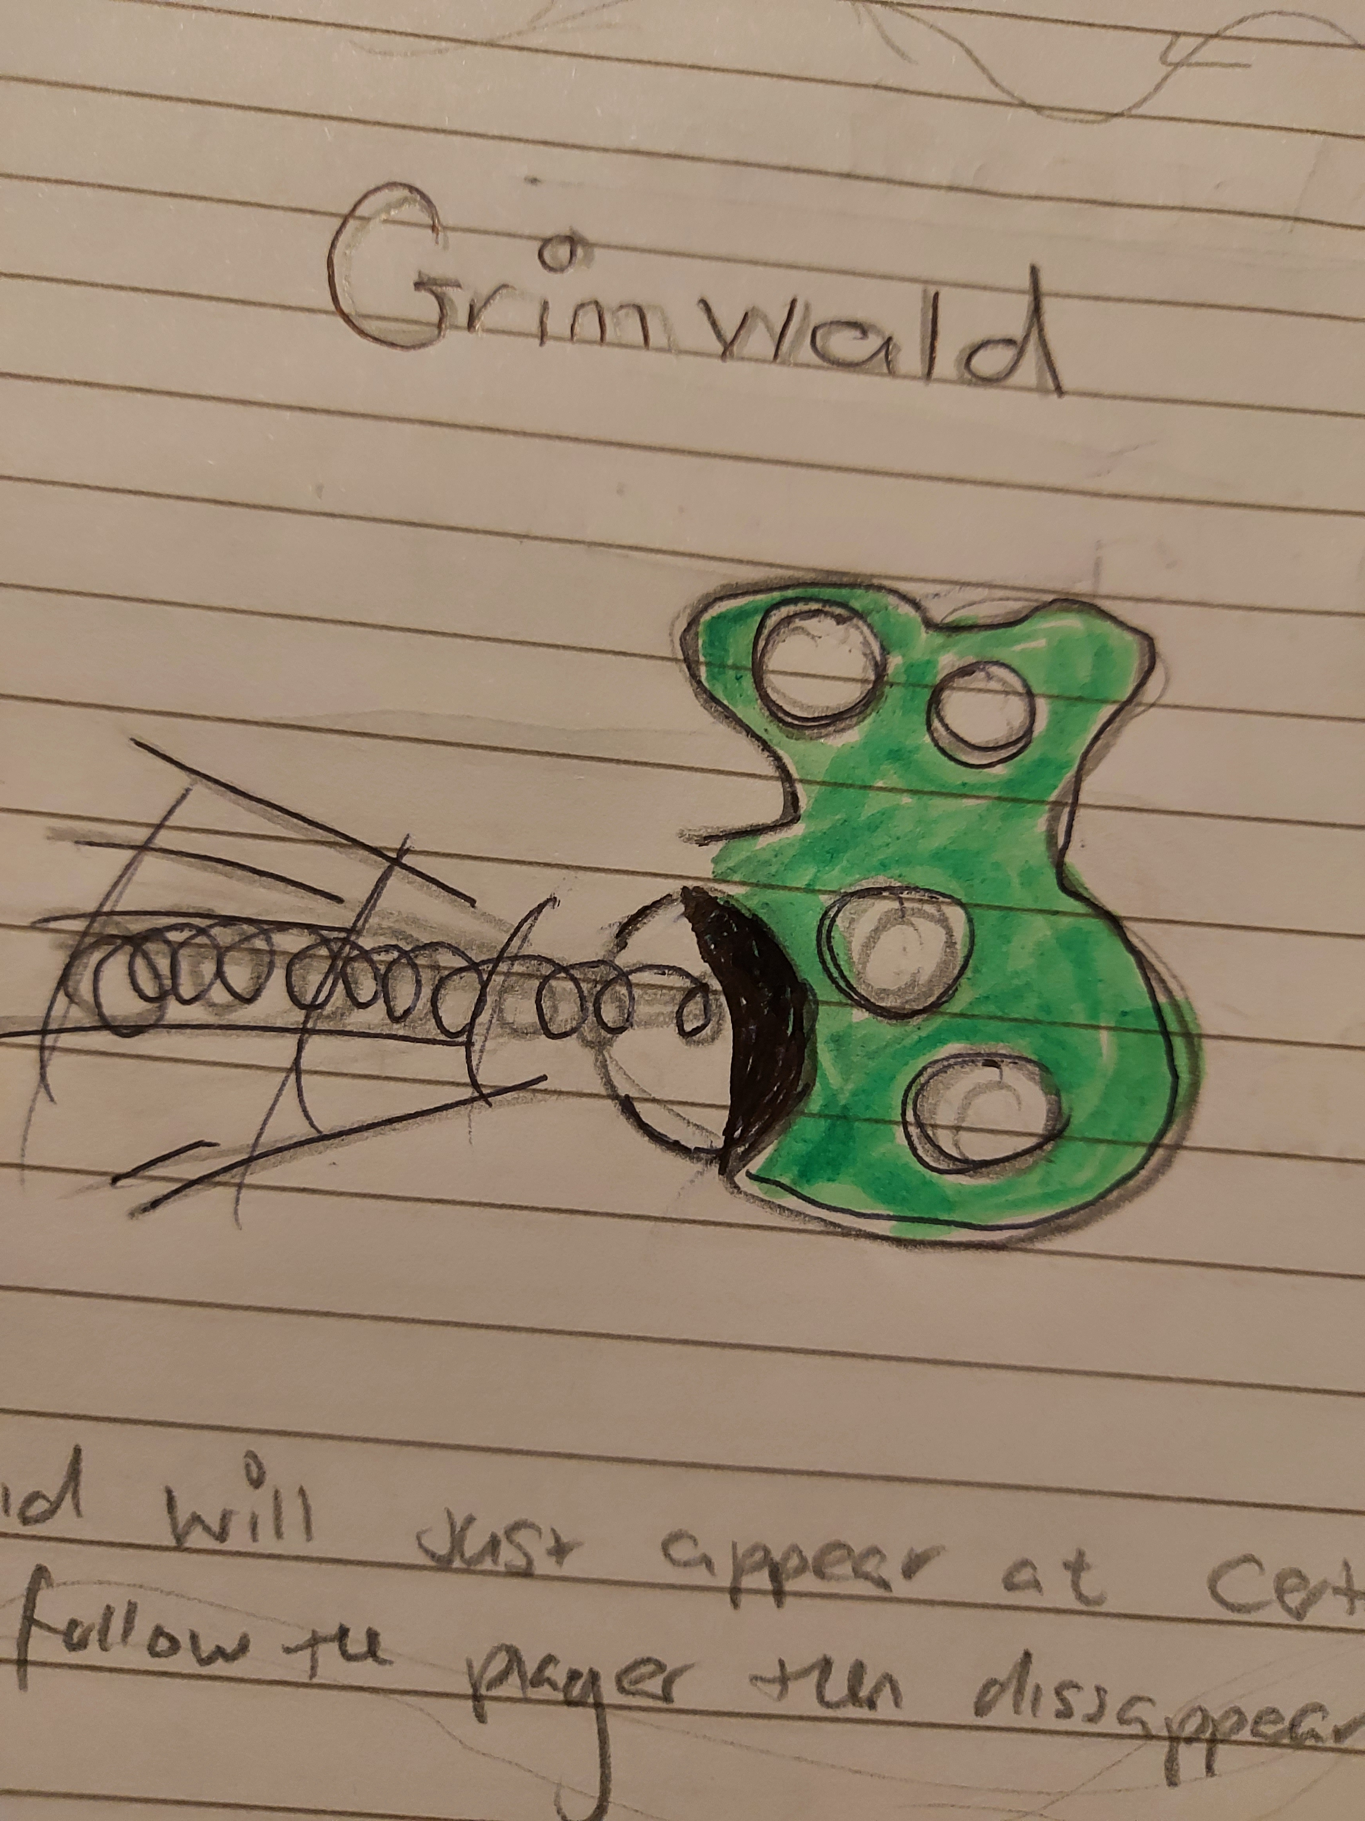
- Glutton

This enemy will clone itself by splitting into two when it takes sufficient damage. These clones are of average speed initially but become faster after splitting.
- Glutton Movement Pattern – The Glutton will split into two, then attack in a C formation before coming back together to form a complete circle.


- Black Holes

These can act as both aids and obstacles, teleporting you to a new area on the screen, either closer to or further from enemies.
- Black Holes Movement pattern – These enemies will teleport in front of the player and then quickly teleport away.
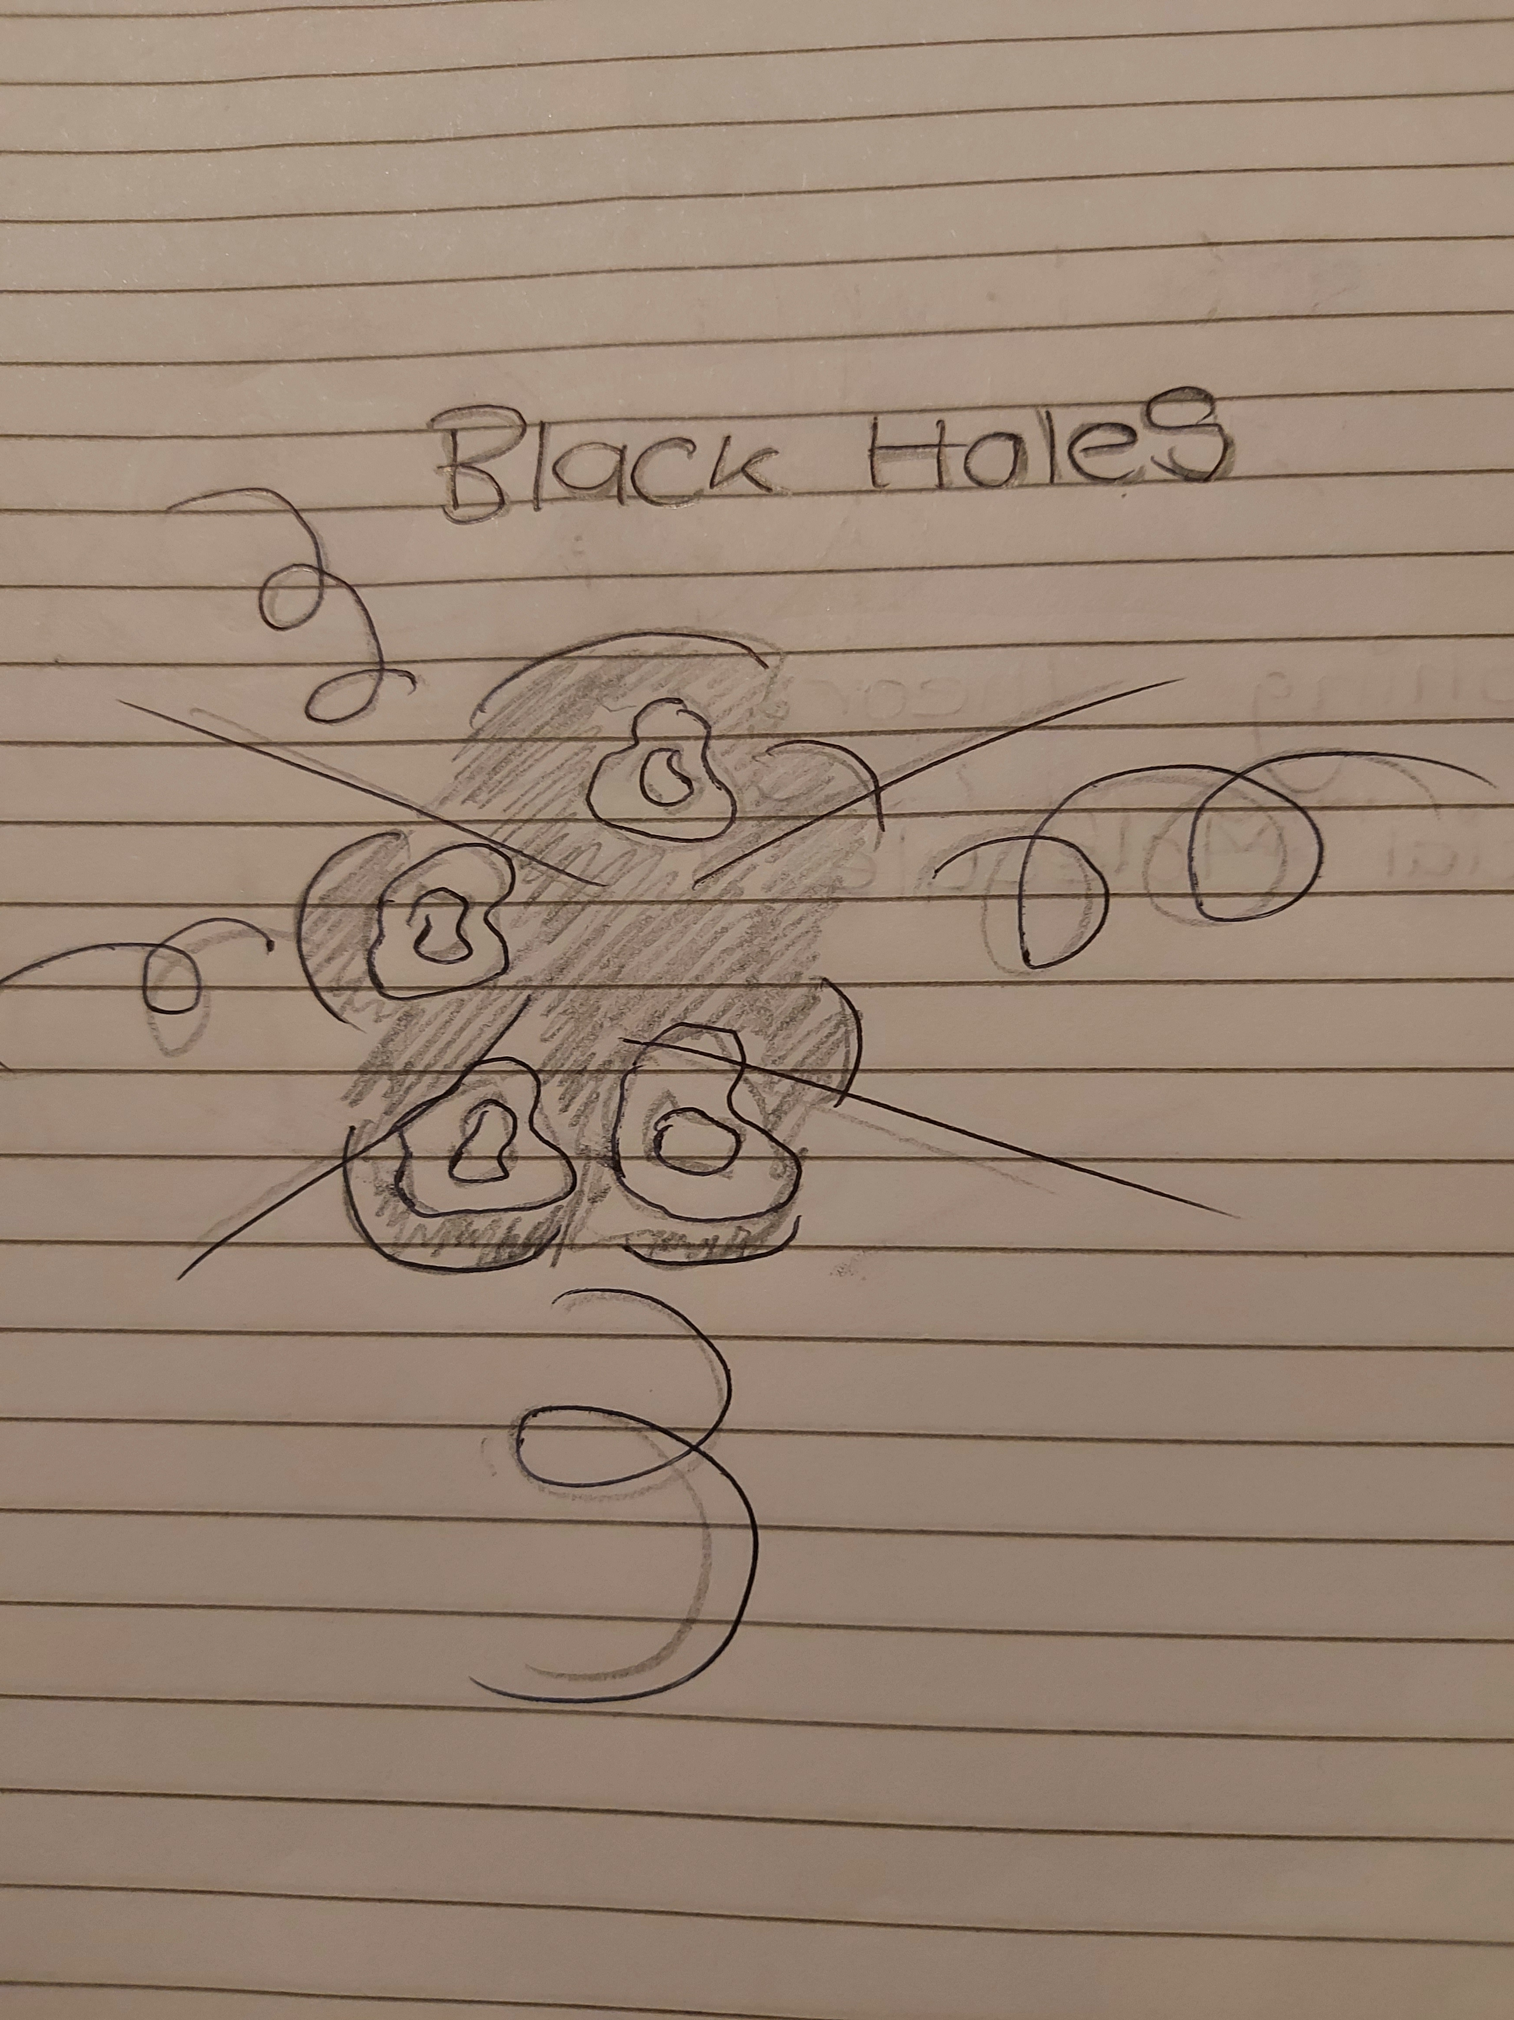

- Game systems 4.3

Game Systems: Progression Systems

- Weapons Systems

The player is encouraged to destroy all enemies, as they will drop high-powered weapons and items that aid in progression. These rewards enhance the player's abilities and provide necessary tools to tackle more challenging levels and enemies as the game advances.

- Automatic Fire – This intuitive gameplay system ensures that the player's ship will automatically fire when it comes into contact with enemies, simplifying combat and allowing the player to focus on navigation and strategy.

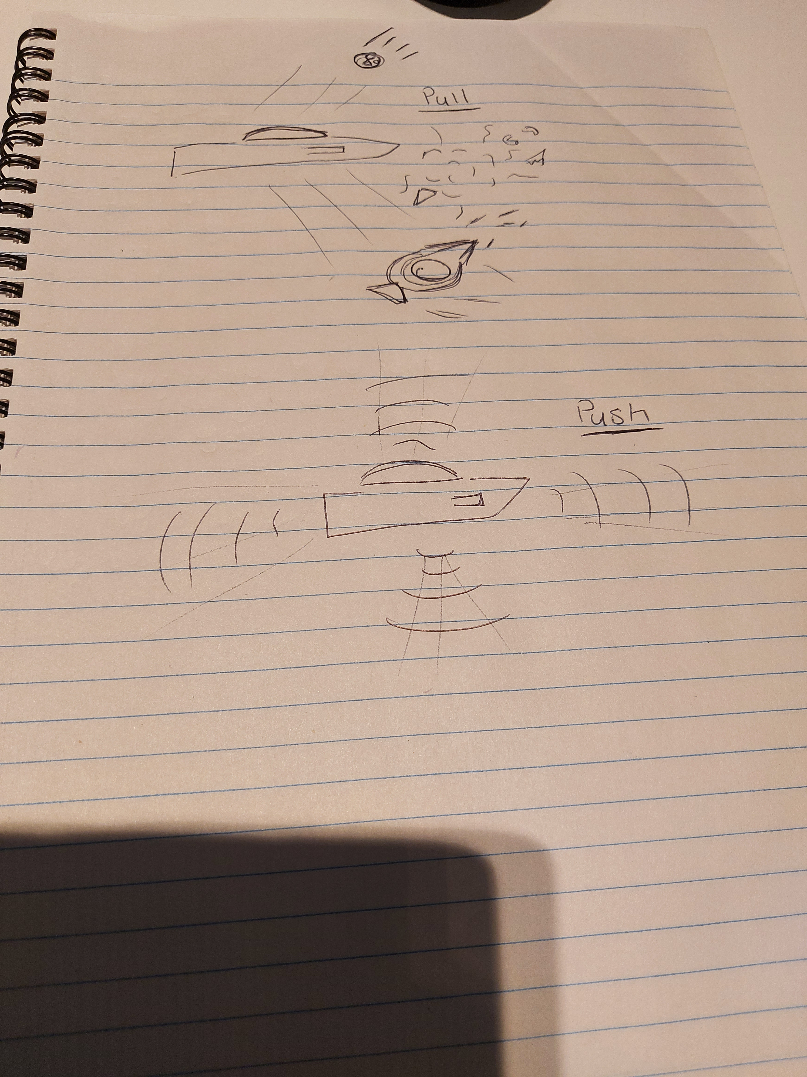

- Dynamic Difficulty System
- Implemented into the game is a dynamic difficulty system that caters to all player skill levels, from novices to experienced players. This system adjusts the game's difficulty settings based on the player's performance, making it more challenging for skilled players and easier for those with less experience.
- Movement

To achieve seamless integration of movement and polarity mechanics, the game will utilize Physics 2D, providing realistic gameplay mechanics and interactions. Additionally, a Unity 2D Sphere class will define the Killzone radius around the ship, ensuring precise and responsive gameplay within this area. This combination will allow for smooth and intuitive interactions as both the player and enemies move dynamically within the game environment.
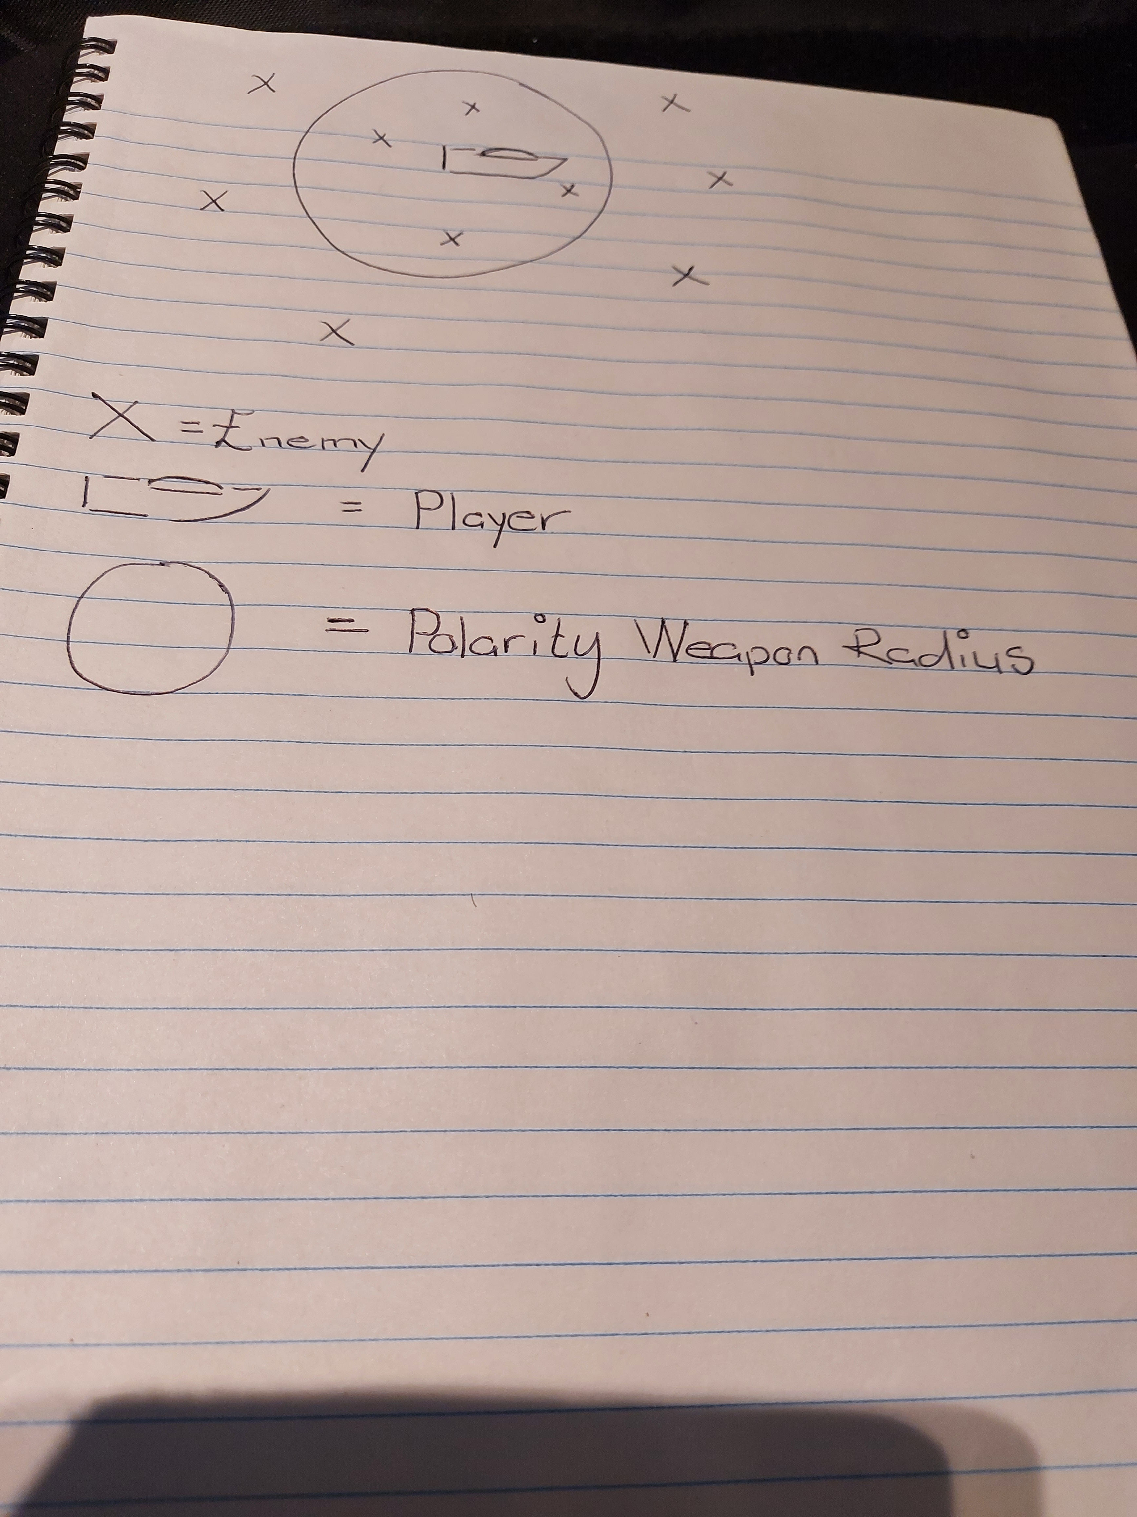

Story 5
In an era where the frontiers of space beckon the brave and the bold, the United States Air Force unveils its latest marvel: a spacecraft engineered to traverse the cosmos at the speed of light itself, aptly named “299 792 458,” the numerical speed of light measured in meters per second. Emblazoned with its call sign, this vessel represents humanity’s pinnacle of exploration and technological prowess.
Yet, as often is the case with groundbreaking advancements, the eyes of envy and malice are never far behind. Nations, driven by hostile intent and insatiable desire for dominance, covertly conspire to seize this technology, aiming to wield its unprecedented capabilities for nefarious purposes.
Amidst this brewing storm of geopolitical intrigue and shadowy machinations, Elia—a seasoned test pilot chosen for her exceptional skills and unwavering courage—ascends to the stars aboard the “299 792 458” for what is to be a routine test flight. Unbeknownst to her, the journey quickly spirals into a perilous saga when an enigmatic adversary launches a sudden, ferocious attack.
With the fate of the “299 792 458” and its revolutionary technology hanging in the balance, Elia finds herself thrust into an escalating conflict that stretches beyond terrestrial boundaries. As she navigates the treacherous expanse of space, evading and confronting threats, a broader conspiracy unfolds, revealing that the stakes of this mission extend far beyond the vessel itself.
The saga of “299 792 458” weaves a gripping tale of innovation, ambition, and peril, challenging the very essence of human courage and resilience. In the vast, unforgiving void, Elia must protect a technological marvel that could herald a new dawn for humanity or become the harbinger of its undoing.

Characters 6

Elia – The Ship Test Pilot Elia is the skilled test pilot of the spaceship. As the protagonist, Elia will navigate various challenges and enemies throughout the game.
The Speed of Light – The Spaceship The Speed of Light is the spaceship that players will control from start to finish. This advanced spacecraft is equipped with powerful weapons and technology, allowing it to face the myriad threats encountered during gameplay.

Gameworld 7
- Unity 2D – Space Parallax Side Scroller with 3D Assets
- The game is designed as a space parallax side scroller using Unity 2D, integrating 3D assets to enhance the visual experience. This combination allows for a dynamic and visually appealing gameplay environment, where the background moves at different speeds to create a sense of depth, while 3D models add realism and detail to the game world.

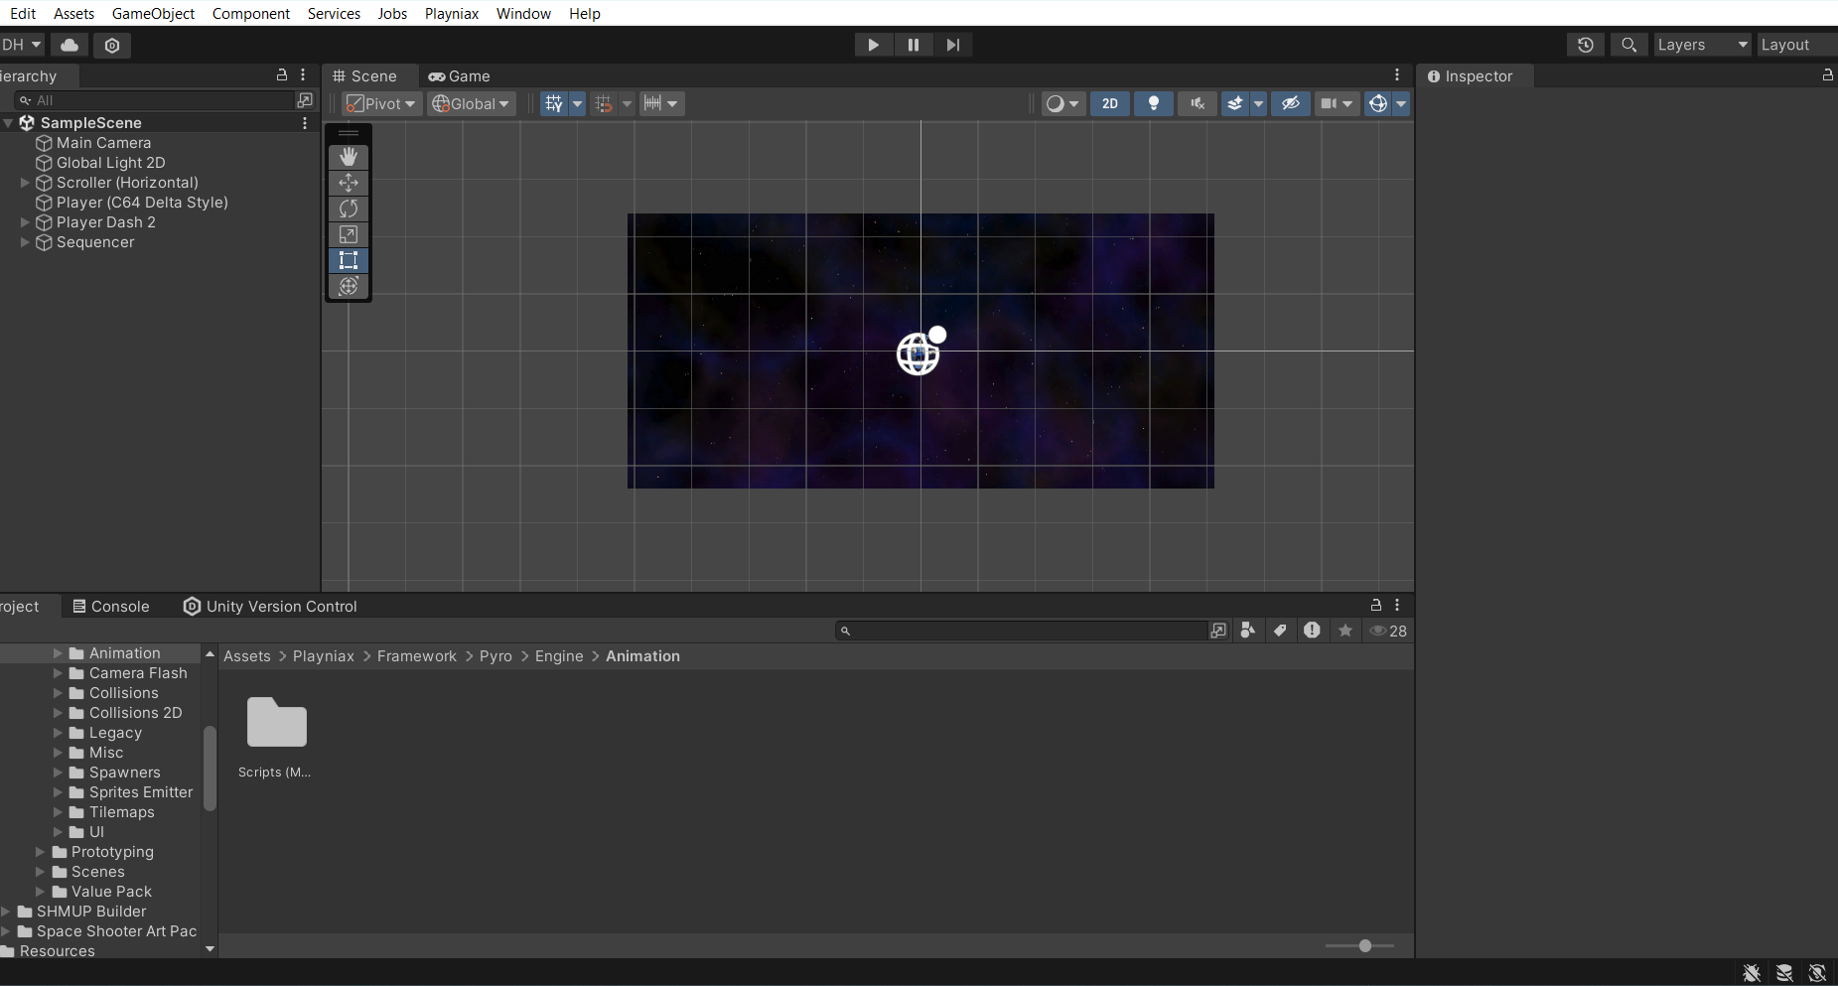

Control scheme 8
- PC Keyboard

The control scheme for the game will utilize only the arrow keys on the keyboard, ensuring simplicity and ease of use. By keeping the controls minimal, the game aims to draw players in and induce a state of flow, allowing them to interact seamlessly with the game world. This straightforward approach ensures that players can quickly become proficient in navigating and engaging with the game.

