Human Circuit Racers

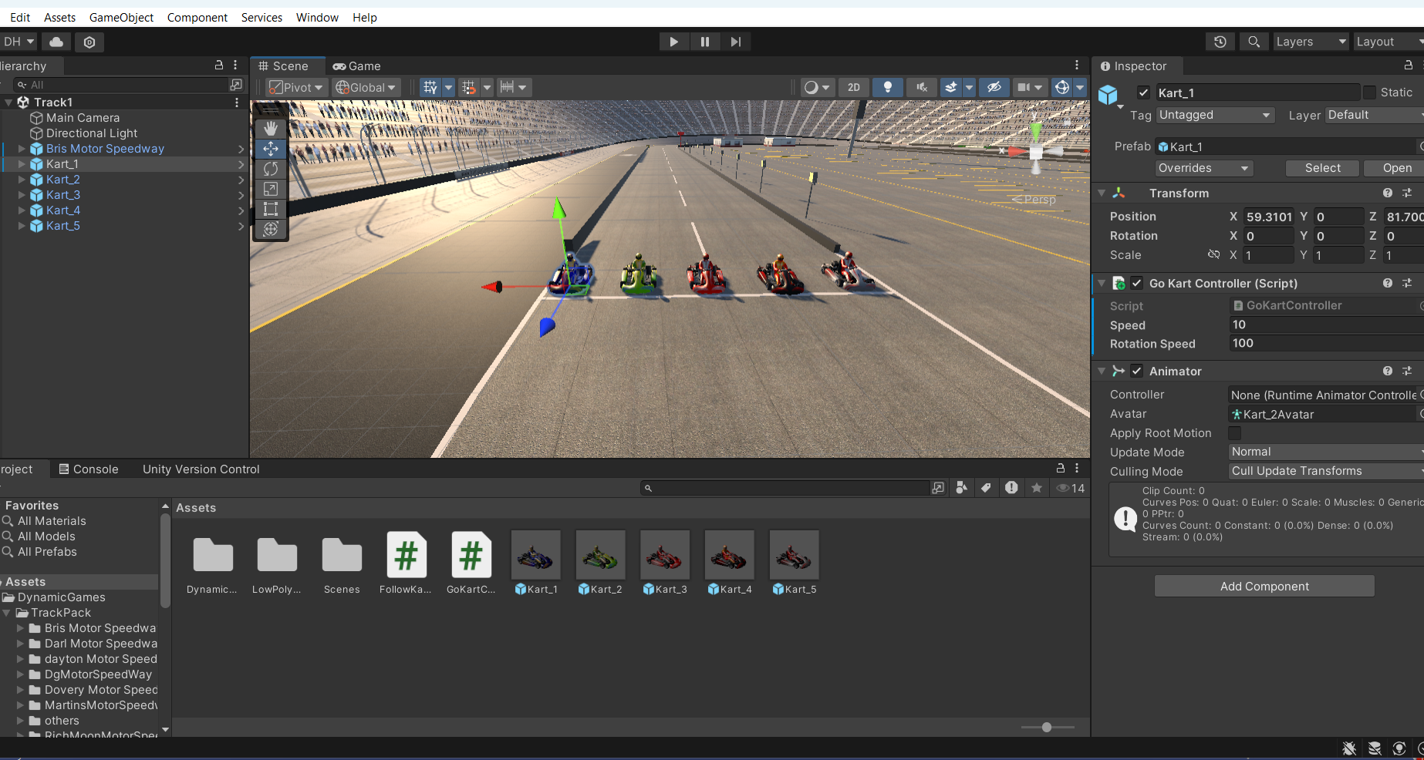

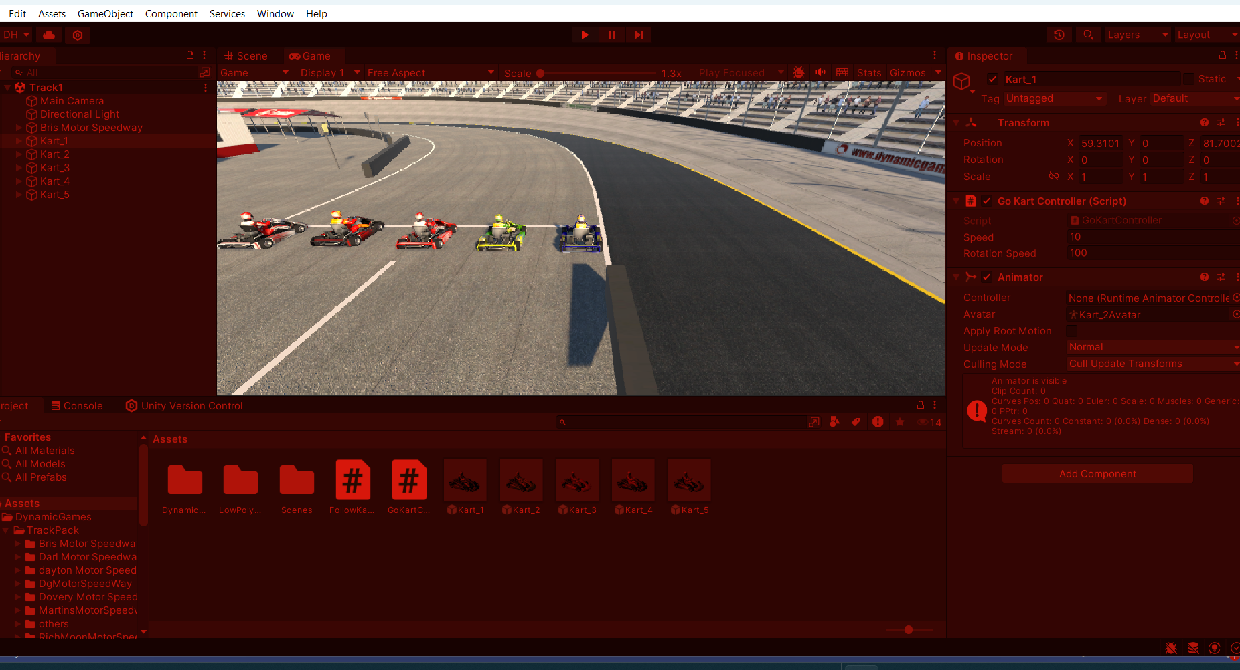

Game Design Document

Last Updated: 19th June 2024
Version: 1.0

Table of contents

Game overview | 1
Design Pillars | 2
Gameplay overview  Core game loop  Genre  Target platforms  Target audience  Game objectives | 3  3.1  3.2  3.3  3.4  3.5
Game mechanics  Player  Game Characters  Game systems | 4  4.1  4.2  4.3
Story | 5
Characters | 6
Game world | 7
Control scheme | 8

Game overview 1
Title: Human Circuit Racers
Genre: Competitive Battle Racing
Platform: Unity 3D
Mode: Single-player
Summary: Human Circuit Racers is an exhilarating single-player competitive battle racing game set to be developed using Unity 3D. Players will have the opportunity to control one of six unique go-karts and compete in a series of challenging racing events. The objective is to achieve the best lap time while contending with AI-controlled non-player characters (NPCs) that serve as formidable opponents. The game emphasizes a competitive atmosphere where players strive to outperform each other in terms of lap times and overall scores across multiple levels.
Core Features:
- Playable Characters:
Up to six unique and zany go-karts available for players to choose from, each with distinct attributes and abilities.
- AI-Controlled Opponents:
Intelligent NPCs that provide a challenging racing experience and simulate real competitive scenarios.
- Scoring System:
Players are ranked based on their lap times and overall performance throughout the racing events.
A dynamic leaderboard that showcases the best players and their achievements.
- Engaging Courses:
A variety of imaginative and whimsical tracks designed to test players' racing skills and strategy.
- Core Gameplay Loop:
Race: Compete in high-octane racing events.
Compete: Battle against AI opponents and strive for the best lap times.
Level Up: Progress through levels by improving performance and mastering each course.
Score: Achieve the best overall score to top the leaderboard.
Gameplay Mechanics:
- Racing Dynamics: Fluid and responsive controls to provide an immersive racing experience.
- Power-ups and Obstacles: Various in-game power-ups and obstacles to add depth and excitement to races.
- Customization: Options for players to customize their go-karts and characters, enhancing personalization and strategy.
Development and Technical Specifications:
- Engine: Unity 3D
- Graphics: High-quality, stylized visuals that complement the whimsical nature of the game.
- Audio: Engaging sound effects and a dynamic soundtrack to enhance the racing atmosphere.
Conclusion:
Human Circuit Racers aims to deliver a thrilling and competitive racing experience with a unique twist. By combining fast-paced gameplay, intelligent AI opponents, and a vibrant, whimsical setting, the game promises to captivate players and provide endless hours of racing fun.

 | Clock – Race against the clock.
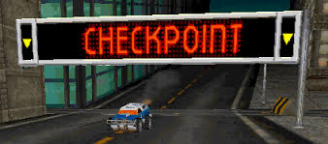 | Checkpoints – Race through checkpoints to extend your time.

Design Pillars 2

Mechanics | - Rules: The game mechanics will be defined by a set of rules that govern gameplay and progression.  - Stats and Reward System: Players will have a stats and reward system akin to RPG (role-playing game) mechanics. This system will allow players to earn points and rewards based on their performance in races.  - Winning System: To win the game, players must complete each of the seven levels by securing first place in each race. This progression system ensures that players continually strive to improve and master each track.  - Customization and Progression: Throughout the game, players will have the opportunity to customize their characters and go-karts using the points they earn. This customization will be available at each stage, allowing for personalized and strategic gameplay.  - Persistent Scoring: The player's best lap time and overall score will be carried across all seven levels. This persistent scoring system encourages consistent performance and adds a layer of strategic depth as players aim to maintain and improve their records.  These features collectively create a dynamic and engaging gameplay experience, blending competitive racing with RPG-style progression and customization.
Technology | • Unity 3D: The game will be developed using Unity 3D, a versatile and powerful game engine that supports multi-platform development and provides robust tools for creating engaging 3D experiences.  • Platform Availability: Human Circuit Racers will be available on all major platforms, ensuring accessibility and a broad reach to players across different devices. This includes consoles, PC, and mobile platforms, leveraging Unity 3D’s capabilities to deliver a consistent and high-quality gaming experience across various hardware.
Story | • Setting: The game is set in a fictional town called Who’s Ville, a vibrant and whimsical place known for its annual comedic sporting event.  • Plot: Each year, the townsfolk of Who’s Ville stage a grand tournament to find the fastest and best racers in the town. This event is a highlight for the community, filled with humor, excitement, and fierce competition.  • Tone: The story will have a lighthearted and comedic tone, complementing the zany characters and imaginative courses in the game. This setting provides a fun and engaging backdrop for the racing events, adding depth and charm to the overall gaming experience.
Aesthetics | • Art Style: The game will feature a colorful cartoon art style, providing a vibrant and visually appealing experience for players.  • Visual Elements: Both the in-game racecourses and characters will be designed with bright, vivid colors, enhancing the whimsical and playful atmosphere of Who’s Ville.  • Consistency: The use of a consistent, colorful aesthetic throughout the game will help to create an immersive and cohesive visual experience, making the game visually engaging and enjoyable for players of all ages.

Gameplay overview 3
• Objective: To compete in Who’s Ville’s national racing tournament, players will need guts, patience, and nerves of steel. The ultimate goal is to win the tournament by securing the grand prize of first place, earning the title of the fastest human circuit racer alive.
• Tournament Structure: Players will participate in the Who’s Ville National Racing Championship Tournament, a series of intense race battles designed to test their racing skills and strategic abilities.
• Skill Development: Throughout the tournament, players will hone their skills, survive intense race battles against formidable opponents, and strategically use power-ups.
• Character Progression: Players can level up their character, enhancing their stats and abilities to improve performance on the track.
• Race Mechanics: Players must aim to achieve the fastest lap times while also scoring points by engaging in battles with their opponents.
• Winning Criteria: The first-place prize in the Who’s Ville National Racing Championship Tournament is awarded to the racer who demonstrates exceptional speed, skill, and strategy, earning the title of the best human circuit racer.

Core game loop 3.1
- Selection:
Choose Character and Kart: Players select from a roster of unique and zany characters and their corresponding go-karts, each with distinct attributes and abilities.
- Preparation:
Customization: Customize the selected character and kart using earned points to enhance performance and personalize the racing experience.
Power-ups: Strategize and choose power-ups to equip before the race.
- Race:
Compete in Races: Engage in high-octane races across a variety of whimsical and challenging tracks.
Battle Opponents: Use skill and strategy to navigate the course, outmaneuver opponents, and utilize power-ups effectively.
Achieve Fastest Lap: Aim for the fastest lap time to gain an edge over competitors.
- Scoring:
Earn Points: Accumulate points based on race performance, including lap times and battle interactions.
Track Progress: Scores and lap times are carried over across all seven levels, contributing to overall standing.
- Progression:
Advance Levels: Progress through the game by completing each of the seven levels, with the requirement of securing first place in each race to move forward.
Level Up Character: Continuously improve character stats and kart capabilities by spending earned points.
- Leaderboard:
Track Ranking: Monitor the leaderboard to see how you rank against other players, aiming to reach the top by the end of the tournament.
- Victory:
Win the Tournament: Secure the first-place prize in the Who’s Ville National Racing Championship Tournament by demonstrating consistent excellence and achieving the best overall score and lap times.
- Replayability:
Repeat and Improve: Players are encouraged to replay levels to improve their lap times, earn more points, and further customize their characters and karts for better performance.
This core game loop ensures a dynamic and engaging experience, with a balance of racing, battling, and strategic customization that keeps players coming back for more.

1st Place | 10 Points
2nd Place | 8 Points
3rd Place | 6 Points
4th Place | 4 Points
5th Place | 2 Points
6th Place | 1 Point

Genre 3.2

- Racing: The primary genre of the game is racing, where players compete in high-speed, adrenaline-filled races on various tracks.
- Battle Racing: Incorporates elements of combat within the racing framework, where players use power-ups and engage in strategic battles against opponents to gain an advantage.
- RPG Elements: Features a robust stats and rewards system similar to role-playing games (RPGs). Players earn points, level up their characters, and customize their go-karts, enhancing their abilities and personalizing their gameplay experience.
This blend of genres creates a unique and dynamic game that combines the thrill of racing with the strategic depth of RPG mechanics and the excitement of battle interactions.

Target platforms 3.3

- Consoles:
PlayStation
Xbox
Nintendo Switch
- PC:
Windows
macOS
Linux
- Mobile:
iOS
Android
Human Circuit Racers aims to be accessible across all major gaming platforms, providing a seamless and engaging experience for players regardless of their preferred device. Unity 3D’s multi-platform capabilities ensure consistent performance and quality across consoles, PCs, and mobile devices.

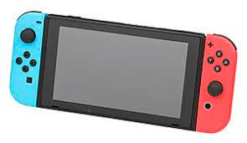

Target audience 3.4

- Age Group:
Primary: 8-16 years old
Secondary: 17-35 years old
- Demographics:
Casual Gamers: Players who enjoy easy-to-pick-up, fun, and engaging gameplay.
Competitive Players: Gamers who thrive on competition and aim for high scores and rankings.
Family-Friendly: Suitable for younger audiences, making it a good choice for family gaming sessions.
- Interests:
Racing Enthusiasts: Fans of racing games who enjoy fast-paced and thrilling racing experiences.
RPG Fans: Players who appreciate character customization, progression systems, and strategic gameplay.
Casual Gamers: Individuals who enjoy light-hearted, colorful, and comedic gaming experiences.
- Geographic Regions:
Global Reach: The game is designed to appeal to a broad international audience, with universal themes of racing and competition.
By targeting these audiences, Human Circuit Racers aims to create an inclusive and enjoyable game that appeals to a wide range of players, offering both depth for dedicated gamers and accessibility for casual players.

Game objectives 3.5

- Win the Tournament:
Compete in the Who’s Ville National Racing Championship Tournament and aim to secure the grand prize by finishing first in each race across all seven levels.
- Achieve Fastest Lap Times:
Strive to achieve the fastest lap times on each track, optimizing performance and mastering course layouts to gain an edge over opponents.
- Earn Points:
Accumulate points by performing well in races, engaging in battles with opponents, and utilizing power-ups effectively. Points contribute to character progression and leaderboard rankings.
- Level Up and Customize:
Continuously improve your character’s stats and abilities by leveling up. Use earned points to customize your character and go-kart, enhancing performance and personalizing the gameplay experience.
- Battle Opponents:
Engage in strategic battles with AI-controlled opponents, using power-ups and tactical maneuvers to outsmart and outpace them on the track.
- Complete All Levels:
Successfully complete all seven levels of the tournament, each with unique challenges and increasingly difficult opponents.
- Top the Leaderboard:
Aim to reach the top of the leaderboard by consistently performing at your best, maintaining the fastest lap times, and achieving high scores across all races.
- Replay and Improve:
Replay races to improve your lap times, earn more points, and refine your racing and battling strategies. Strive for continuous improvement and mastery of the game.
These objectives ensure a dynamic and engaging gameplay experience, encouraging players to hone their skills, strategically compete, and continuously seek improvement.

1-Battle your opponents | Race and battle your opponents for first place
2-Get the best lap time | You will be awarded 10 points for first place. Your best lap time will be recorded and carried across to the next stage.
3-Increase your score | This is the players overall score which will be totaled up and will count towards their overall standing on the leaderboard at the end of the level.
4-Level up your character at the end of the race | After each level is over the players score will be totaled up. And points for leveling up your character will be awarded.

Game mechanics 4

- Racing Dynamics:
Controls: Fluid and responsive controls for steering, accelerating, and braking, ensuring a smooth and engaging racing experience.
Boosts: Temporary speed boosts available through power-ups or specific actions like drifting or hitting speed zones.
- Combat Elements:
Power-ups: Various power-ups scattered throughout the track, providing temporary advantages such as speed boosts, shields, or offensive weapons to disrupt opponents.
Battles: Engage in direct combat with opponents using power-ups and strategic maneuvers to gain an edge and hinder their progress.
- Customization and Progression:
Character Stats: RPG-like stats system where players can upgrade attributes such as speed, handling, and durability using earned points.
Customization: Options to customize the appearance and performance of go-karts and characters, enhancing personalization and strategic depth.
- Scoring System:
Lap Times: Track and display the best lap times for each race, encouraging players to improve their performance.
Points: Earn points based on race placement, lap times, and battle performance. Points contribute to overall scores and character progression.
- Level Progression:
Unlock Levels: Complete races to unlock subsequent levels, each with unique tracks and increasing difficulty.
First Place Requirement: Players must secure first place in each race to advance to the next level, adding a layer of challenge and achievement.
- Persistent Scoring:
Carry Over Scores: Best lap times and overall scores are carried across all seven levels, encouraging consistent performance and strategic planning.
- Leaderboards:
Rankings: Dynamic leaderboards that display the top players based on their scores and lap times, fostering a competitive environment.
- Replayability:
Challenges and Achievements: Various in-game challenges and achievements to encourage replayability and mastery of the game.
Improvement: Players are encouraged to replay levels to improve their lap times, earn more points, and refine their strategies.
These mechanics combine to create an engaging, competitive, and strategic gameplay experience, blending fast-paced racing with RPG elements and combat dynamics.

Player 4.1

The selectable and playable characters that will be chosen as racers from the games title screen.

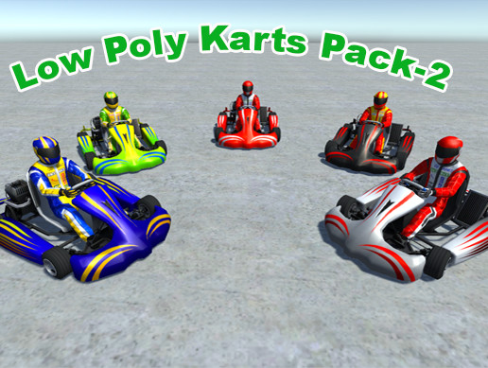 | 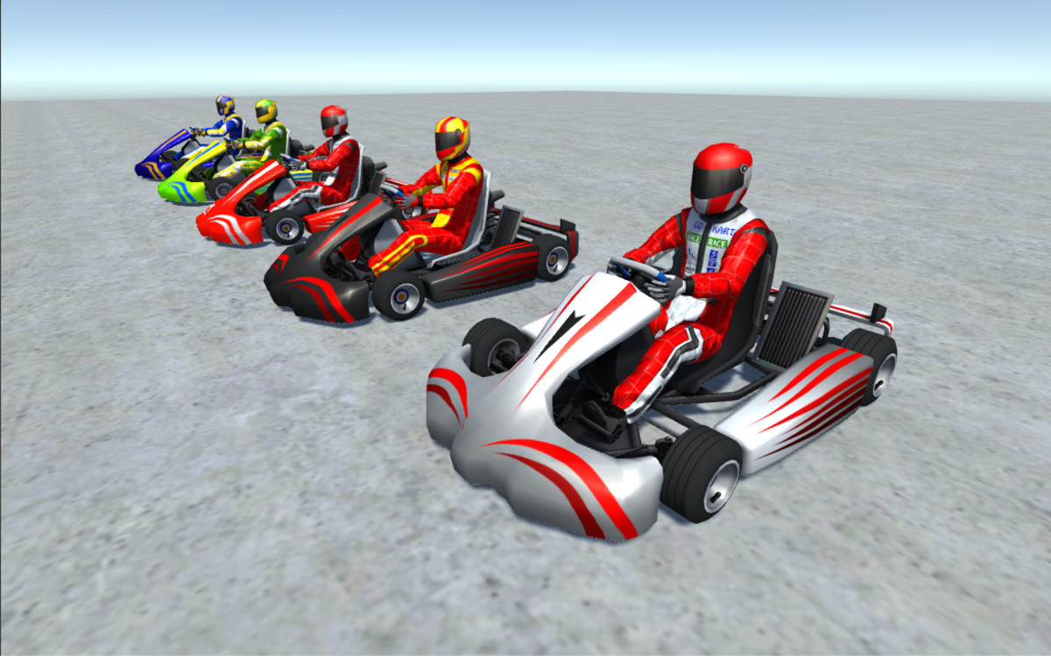 | 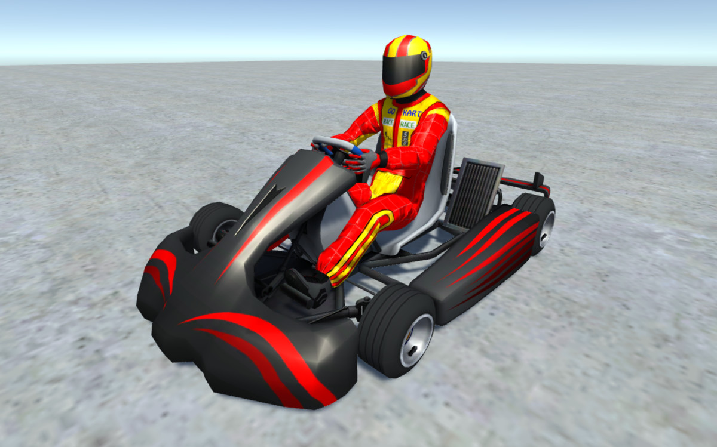 | 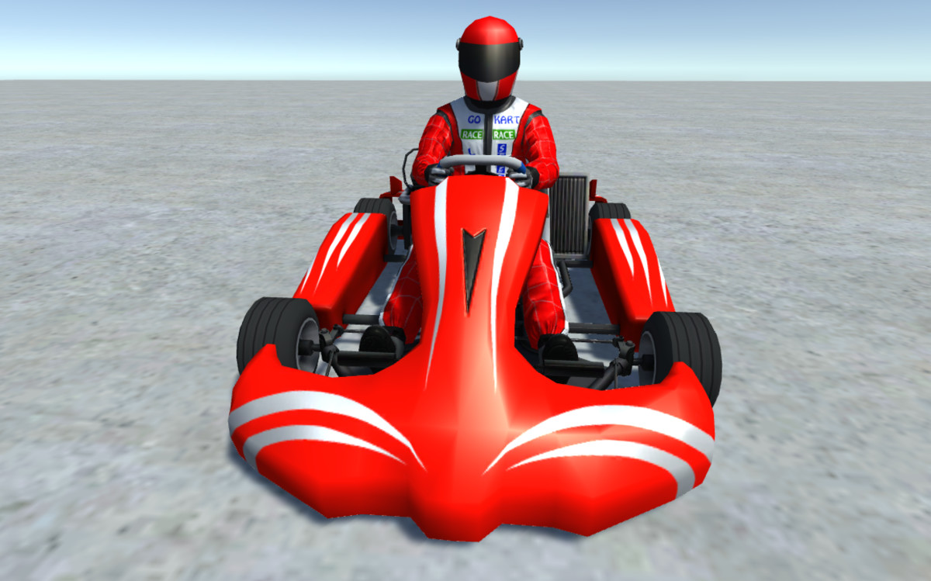 | 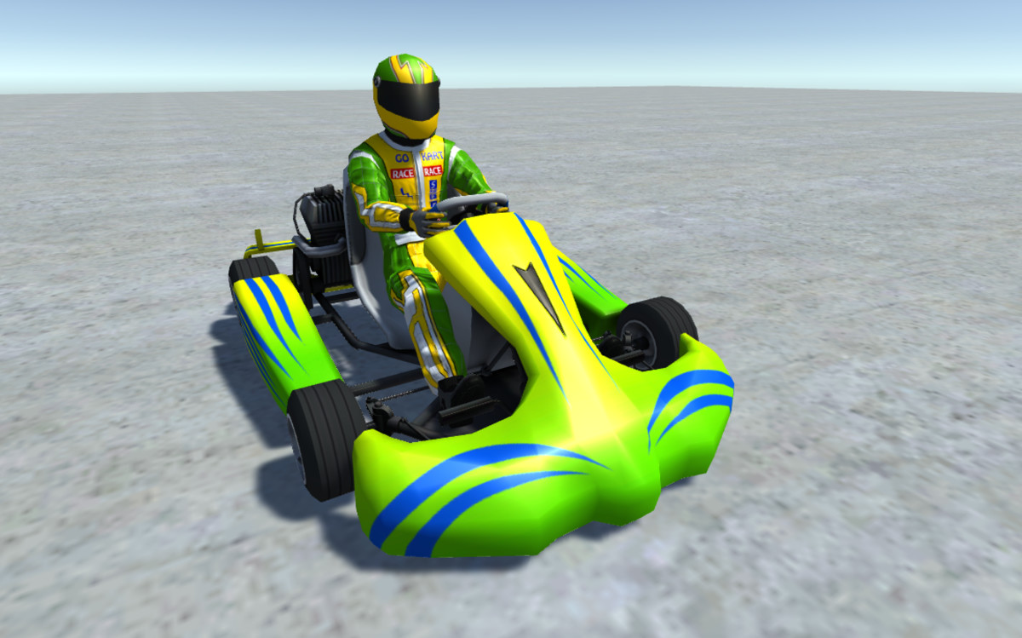 | 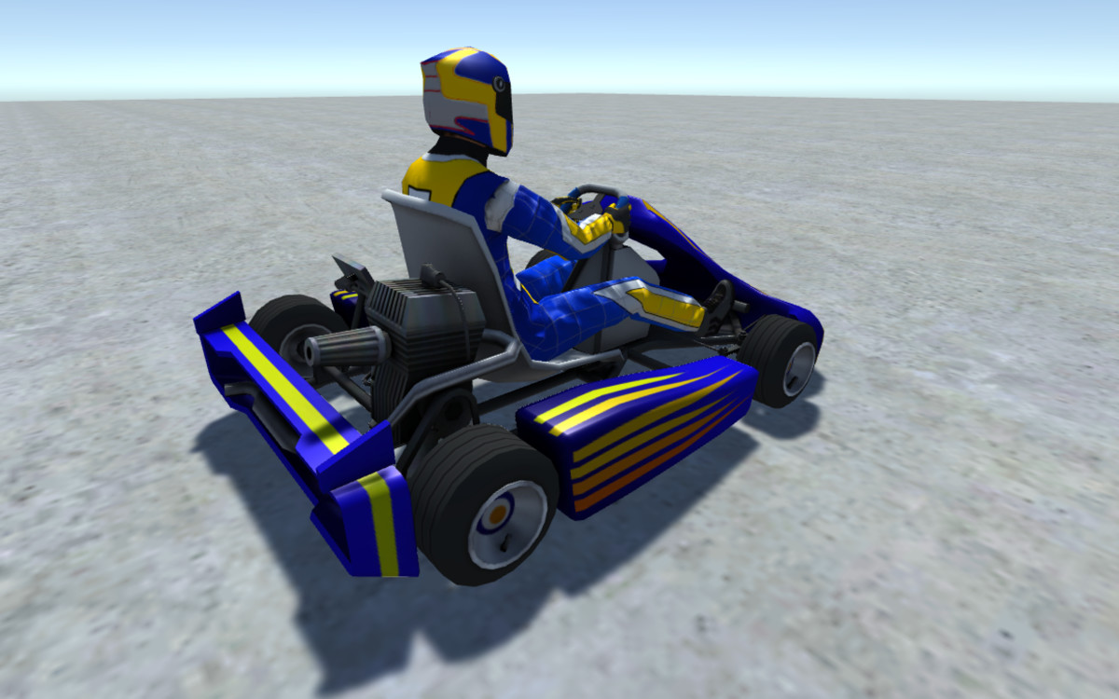
Go-Karts | Jacob | Sean | Lucile | Aya | Wendy

Game characters 4.2

Each character will have their own gameplay traits and back stories.

Players | Synopsis
 | Jacob – is 28 and has something to prove to his friends and family so enters the tournament.
 | Sean – Is 30 and loves racing and plans to make a name for himself.
 | Lucile – Plans to take the winnings from the race and build herself a new house in who’s Ville.
 | Aya – Is 19 her mother is sick with fever she plans to buy medicine for her mother if she wins.
 | Wendy – Is 16 she enters the tournament so that she and her family can use the winnings to leave who’s Ville.

Game systems 4.3

- Control System:
Input Handling: Supports various input methods (controller, keyboard, touch) to ensure smooth and responsive controls across different platforms.
Customization: Players can customize control settings to suit their preferences.
- AI System:
NPC Behavior: Advanced AI for non-player characters, providing challenging opponents with varying difficulty levels.
Adaptive AI: AI that adjusts difficulty based on the player’s performance to maintain a balanced and engaging experience.
- Physics System:
Realistic Physics: Accurate simulation of vehicle dynamics for a realistic racing experience.
Arcade Physics: Adjustments to ensure fun and accessibility, balancing realism with the game’s cartoonish style.
- Power-up System:
Generation and Placement: Randomized power-up placements on tracks to ensure dynamic gameplay.
Effects: Diverse power-ups with unique effects, such as speed boosts, shields, and offensive weapons.
- Progression System:
Leveling Up: Players earn experience points (XP) and level up their characters, unlocking new abilities and upgrades.
Unlockables: New karts, characters, and customization options unlocked through progression.
- Scoring System:
Point Calculation: Points awarded based on race performance, including placement, lap times, and combat effectiveness.
Leaderboard Integration: Scores are tracked and displayed on global and local leaderboards.
- Customization System:
Character and Kart Customization: Extensive options for players to personalize their characters and vehicles, affecting both aesthetics and performance.
Upgrade Paths: Multiple upgrade paths for enhancing character stats and kart capabilities.
- Economy System:
In-game Currency: Players earn currency through races and battles, used for purchasing upgrades and customization items.
Microtransactions (Optional): Potential for in-game purchases to buy exclusive items or accelerate progression.
- Multiplatform Support:
Cross-platform Play: Ensures a seamless experience across different devices, allowing players to compete with friends regardless of their platform.
Save Syncing: Cloud-based save system to synchronize progress across multiple devices.
- Audio-Visual System:
Graphics: High-quality, stylized visuals with vibrant, cartoonish art.
Sound Effects and Music: Dynamic soundtrack and engaging sound effects to enhance the racing atmosphere.
- User Interface (UI) System:
HUD: Intuitive heads-up display (HUD) providing essential information such as speed, lap times, power-up status, and position.
Menus: User-friendly menus for navigating game modes, settings, and customization options.
- Replay System:
Instant Replay: Allows players to review their races, showcasing key moments and battles.
Share Functionality: Options to share replays on social media or with friends.
These systems work together to create a cohesive, engaging, and enjoyable gaming experience, blending racing, combat, and RPG elements seamlessly.

Story 5

Setting:
- The game is set in Who’s Ville, a vibrant and whimsical fictional town known for its annual comedic sporting event.
Plot:
- Each year, the residents of Who’s Ville eagerly await the National Racing Championship Tournament, a grand event designed to find the fastest and best racers in the town. The tournament is a highlight of the town’s calendar, filled with humor, excitement, and fierce competition.
Characters:
- Protagonist: The player takes on the role of a determined racer aiming to claim the title of the fastest human circuit racer alive. The protagonist is one of the six unique characters available for players to choose from, each with their own backstory and motivations.
- Opponents: The player competes against a variety of AI-controlled racers, each with distinct personalities and racing styles, adding depth and challenge to the races.
Tone:
- The story is lighthearted and comedic, complementing the game’s colorful cartoon art style and whimsical setting. The humor and playful atmosphere are designed to appeal to players of all ages.
Objective:
- To win the Who’s Ville National Racing Championship Tournament, players must demonstrate skill, strategy, and perseverance. The ultimate goal is to finish first in each of the seven levels, earning the grand prize and the title of the best human circuit racer in Who’s Ville.
Progression:
- As the player advances through the tournament, they will face increasingly difficult opponents and more challenging tracks. The player’s journey involves honing their racing skills, engaging in intense battles, and continuously upgrading their character and kart.
Climax:
- The final race of the tournament is the most challenging, bringing together all the skills and upgrades the player has acquired. Success in this race not only secures the grand prize but also cements the player's reputation as the fastest racer in Who’s Ville.
Conclusion:
- Upon winning the tournament, the player is celebrated as the champion of Who’s Ville. The victory is marked by a humorous and heartwarming closing ceremony, reflecting the game’s overall lighthearted tone.
Replayability:
- The story encourages replayability by offering different characters to choose from, each with their own unique storylines and endings. Additionally, players can replay races to improve their lap times and scores, further enhancing their mastery of the game.
This story framework provides a captivating and engaging narrative backdrop for the racing and competitive elements of Human Circuit Racers, blending humor, challenge, and progression into a compelling gaming experience.

Characters

Characters | Back-story
 | Jacob – Jacob’s family come from a long line of racers and sees winning the tournament as a sense of pride.
 | Sean - Has grown up around the tournament and is somewhat of an enthusiastic racer.
 | Lucile – grew up poor and just wants enough money to live comfortably
 | Aya – doesn’t really like racing but needs the money for her sick mother.
 | Wendy – and her family hate who’s Ville and can’t wait to leave.

Game world 7
Setting:
- Who’s Ville: A whimsical and vibrant fictional town that serves as the backdrop for the game. The town is characterized by its colorful and imaginative design, reflecting a playful and cartoonish aesthetic.
Environments:
- Urban Streets:
Description: The bustling heart of Who’s Ville, filled with winding roads, tight corners, and a mix of modern and quirky buildings.
Challenges: Sharp turns, traffic, and occasional obstacles like pedestrians and street vendors.
- Countryside:
Description: Lush green fields, rolling hills, and scenic landscapes provide a refreshing contrast to the urban environment.
Challenges: Uneven terrain, natural obstacles like rocks and trees, and wildlife that can cross the track.
- Amusement Park:
Description: A lively and chaotic area filled with roller coasters, Ferris wheels, and carnival games.
Challenges: Moving parts of rides, bright lights, and sounds that can distract and disorient racers.
- Desert Dunes:
Description: A vast, sandy expanse with towering dunes and ancient ruins scattered throughout.
Challenges: Sandstorms, shifting sands, and hidden shortcuts within the ruins.
- Snowy Mountains:
Description: Majestic, snow-covered peaks with icy tracks and frozen lakes.
Challenges: Slippery surfaces, sudden avalanches, and extreme weather conditions.
- Haunted Forest:
Description: A dark, eerie forest with twisted trees, glowing eyes, and mysterious fog.
Challenges: Limited visibility, ghostly apparitions, and tricky paths that can lead to dead ends.
- Underwater City:
Description: A submerged, fantastical city with glass tunnels, colorful coral reefs, and exotic marine life.
Challenges: Water currents, aquatic creatures, and occasional leaks that create temporary hazards.
Landmarks and Points of Interest:
- Town Square: The central hub of Who’s Ville, where players can gather, customize their characters, and access various game features.
- Grand Stadium: The starting point for the National Racing Championship Tournament, a grand and colorful arena where major events take place.
- Workshop: A place for players to upgrade and customize their karts, located in a cozy garage run by a friendly mechanic.
- Marketplace: A bustling area where players can purchase power-ups, costumes, and other items using in-game currency.
Dynamic Elements:
- Weather Conditions: Changing weather patterns that affect track conditions, such as rain, snow, and fog, adding variety and challenge to races.
- Day-Night Cycle: A dynamic day-night cycle that alters the ambiance and visibility of the tracks, providing a fresh experience each time a race is revisited.
Interactive Elements:
- Track Hazards: Various interactive elements on the tracks, such as moving barriers, exploding barrels, and speed boosts that players can utilize or avoid.
- NPC Interactions: Townsfolk and creatures that react to the player’s presence, providing a lively and immersive environment.
Overall Aesthetic:
- The game world of Who’s Ville is designed to be colorful, playful, and full of life, with a consistent cartoon art style that ties all the diverse environments together. This aesthetic not only appeals to a wide range of players but also enhances the lighthearted and humorous tone of the game.
This detailed game world provides a rich and immersive backdrop for Human Circuit Racers, combining diverse and imaginative environments with dynamic and interactive elements to create an engaging and enjoyable racing experience.

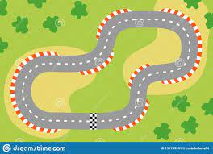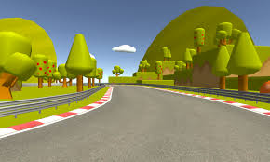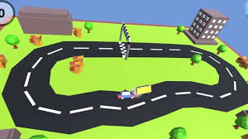

Control scheme 8

Controls

Drive Forward / Backwards / Steer
Arrow Keys / WASD keys
